The ALMA Spectral Line Catalog: Splatalogue

NAASC-00.00.00.10-002-A-PLA

Version: B.2
Status: FINAL

2010-09-27

Prepared By: | Organization | Date
Anthony J. Remijan  Mark Lacy | NRAO  NRAO | 2010-09-27
Approved by: | Organization | Date
Anthony J. Remijan | NRAO
Released by IPT Lead(s): | Organization | Date

Introduction
Splatalogue is a spectral line database developed at NRAO. It is a compilation of data from several external lists and databases, and also includes a front-end webpage for direct queries. Splatalogue is used as a reference source for spectral line data by several ALMA software tools, including the Observing Tool (OT) and CASA. In addition, it is likely to be used for the ALMA Science Archive (ASA) spectral line searches. This memo describes the process whereby data are included in Splatalogue, reconciliation of different database formats and the assignment of “NRAO recommended frequencies” where different values are found in different databases, and presents the plan for management and development of the database and front end.

In this memo, we address the following:

- Motivation and Description of the Current Database
- Procedure for Referencing External Databases
  - Procedure for Accepting New Data into Splatalogue
- Description of Currently Included Databases
- Procedure for Assigning NRAO Recommended Rest Frequencies
- Quantum number Format and Reconciliation scheme
- Version control scheme
- Release schedule
- Regression testing
- Management and Oversight (Spectral Line Working groups NRAO/International)
- Proposed criterion for offline subsets for OT and CASA and how they will be maintained and updated
- Virtual Astronomical Observatory (VAO) Interface
- Vision for Future Splatalogue Interaction with other Spectral Line Databases

- Motivation and Description of the Current Database
The next generation of powerful radio and millimeter/submillimeter observatories (e.g. EVLA, ALMA & Herschel) require extensive resources to help identify spectral line transitions. The ALMA Spectral Line Catalog (Splatalogue) is an attempt to collate, rationalize and extend existing spectroscopic resources for use by the astronomical community. Until the concept of Splatalogue, the astronomical community referenced primarily three publically available online catalogs. The Jet Propulsion Laboratory (JPL) database, the Cologne Database of Molecular Spectroscopy (CDMS) and the Lovas/National Institute of Standards and Technology (NIST) database. Together, these provide an enormous amount of data – collecting the data in all three online databases generates over 3.5 million transition data entries across almost 700 molecular species.
Currently, Splatalogue is a transition-resolved (see section 5.) compilation of the JPL (http://spec.jpl.nasa.gov/), CDMS (http://www.cdms.de/), the Lovas/NIST List (http://physics.nist.gov/cgi-bin/micro/table5/start.pl), Frank Lovas' own Spectral Line Atlas of Interstellar Molecules (SLAIM), data from the Toyama Microwave Atlas for spectroscopists and astronomers (http://www.sci.u-toyama.ac.jp/phys/4ken/atlas/), new methanol data provided by Li-Hong Xu from The University of New Brunswick, Canada (which can be found under the "LISA Lines" Line List selection), experimental laboratory data from Frank De Lucia's lab at The Ohio State University, H, He and C recombination lines, and selected atomic transition. Currently, Splatalogue contains over 5.8 million lines in 1038 individual entries
2. Procedure for Referencing External Databases
The Splatalogue effort would not be possible without the efforts of laboratories all over the world. Data from the publically available catalogs such as JPL and CDMS are updated in Splatalogue as new species or updates to existing species are reported by these existing online catalogs. In the last column of any search with Splatalogue, is displayed the "LineList" where the data originated. For these data, off the main Splatalogue home page you will notice the following references to each lab group that has provided the data:
- CDMS: H. S. P. Müller, F. Schlöder, J. Stutzki, and G. Winnewisser, J. Mol. Struct. 742, 215-227 (2005)
- JPL: H. M. Pickett, R. L. Poynter, E. A. Cohen, M. L. Delitsky, J. C. Pearson, and H. S. P. Muller, "Submillimeter, Millimeter, and Microwave Spectral Line Catalog," J. Quant. Spectrosc. & Rad. Transfer 60, 883-890 (1998).
- Lovas/NIST: F.J. Lovas and R.A. Dragoset (2004), NIST Recommended Rest Frequencies for Observed Interstellar Molecular Microwave Transitions - 2002 Revision, (version 2.0.1). [Online] Available: http://physics.nist.gov/restfreq [2009, February 4]. National Institute of Standards and Technology, Gaithersburg, MD. Optional addition: Also published as J. Phys. Chem. Ref. Data 33(1), 177-355 (2004).
- ToyaMA: Toyama Microwave Atlas for spectroscopists and astronomers is available at: http://www.sci.u-toyama.ac.jp/phys/4ken/atlas/ and thanks goes out to Kaori Kobayashi (University of Toyama) and her collaborators for making these data available to the astronomical community.
- LISA Lines: Currently, this line list contains new methanol data provided by Li-Hong Xu from The University of New Brunswick, Canada.
- OSU: Experimental Intensity Calibrated Spectra as a Function of Temperature. Thanks goes out to Frank De Lucia and his collaborators at The Ohio State University for making their data publically available to the astronomical community.
- SLAIM: In referencing SLAIM, use the following "All spectral line data were taken from the Spectral Line Atlas of Interstellar Molecules (SLAIM) (Available at http://www.splatalogue.net). (F. J. Lovas, private communication, Remijan et al. 2007)"
Finally, when possible, an individual transition may be referenced. In the left hand frame, under the Miscellaneous tab, you will be able to choose “Lovas Lab Ref” and “Lovas Ast Ref” as part of the display of transitions from SLAIM and the Lovas/NIST list. When this is selected, a reference for each transition listed in those databases is available through a small “pop-up” window as illustrated below. Splatalogue is very aware of the need to properly reference data so we make every effort to accurately report where the data contained in Splatalogue comes from.
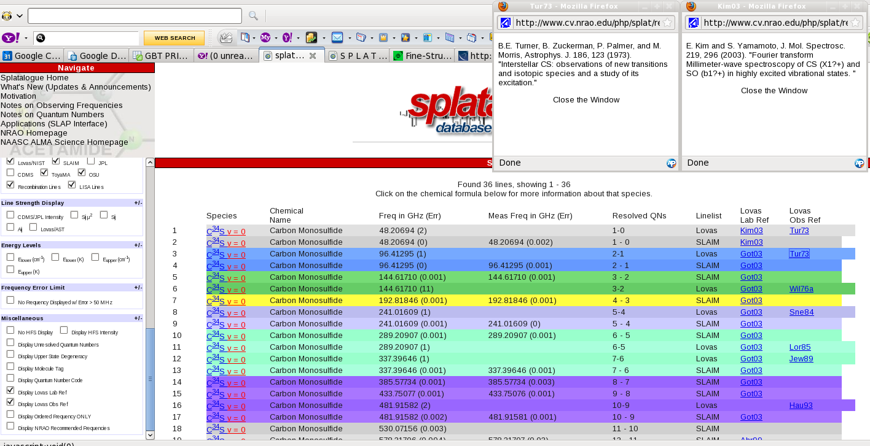
2.1 Procedure for accepting new data into Splatalogue
Data for inclusion into Splatalogue should be are sent via email or other personal correspondence to the authors of Splatalogue at splatalogue@nrao.edu. At any time, questions, comments, or criticism can be sent to the authors of Splatalogue. When we receive the data from the laboratories, we ask for a complete description of the data they are sending including units of transition frequency, line strength, and energy level. In addition, we request comments on the line fitting parameters including upper limits to the total angular momentum (J) or the projection of J onto the various axes of symmetry (Ka and Kc). Finally, we ask for an appropriate reference to the data if it is available in the literature, a laboratory identifying name (e.g. SLAIM) and any other comments on the transitions reported. These data are then included into the Splatalogue database and made available to the lab group via the online web interface. In addition, Splatalogue reports where the data presented came from, both off the main page and each transition is labeled with a reference after a search is conducted.
Many labs have already either provided data or agreed, in principle, to providing laboratory data to Splatalogue. If a formal agreement is necessary between Splatalogue and the laboratories, such an agreement can be generated and signed by the constituent members.
3. Description of Currently Included Databases
Splatalogue currently contains seven databases of molecular line data. These molecular data populate various fields and metadata as made available from each lab group. The table below summarizes the type of data that are available in each catalog. In addition, we give a more complete description where we describe the relevant spectroscopic data available in each catalog.
 | Molecular Name and Formula | Predicted Frequency | Measured Frequency | Quantum Numbers | Transition State Energy Levels | Upper State Degeneracy | Transition Line Strength | Species Metadata Table
JPL | X | X | X | X | X | X | X | X
CDMS | X | X | X | X | X | X | X | X
Lovas/NIST | X | X |  | X |  |  | X | X
SLAIM | X | X | X | X | X | X | X | X
ToyaMA | X |  | X | X | X | X | X | X
OSU | X |  | X |  | X |  | X | X
LISA Lines | X | X | X | X | X | X | X | X

JPL - Data from JPL contain:
- Molecular Name and Formula
- Predicted transition frequency and error OR laboratory measured frequency and error (see section 4.)
- Transition quantum numbers (QNs) in Pickett format AND resolved (QNs) (see section 5.)
- Transition upper state degeneracy, upper state energy (cm⁻¹ and K) and lower state energy (cm⁻¹ and K)
- Transition line strength as measured at 300K in the lab (CDMS/JPL Intensity in Splatalogue display), Sijμ² (D²), Aij (s) and Sij (when possible)
- Species metadata tables that contain: dipole moments, partition functions (range in temperature from 9.275 to 300K), molecular A, B and C constants (where applicable) and references to previous lab work or predictions.

CDMS – Data from CDMS contain:
- Molecular Name and Formula
- Predicted transition frequency and error OR laboratory measured frequency and error (see section 4.)
- Transition quantum numbers (QNs) in Pickett format AND resolved (QNs) (see section 5.)
- Transition upper state degeneracy, upper state energy (cm⁻¹ and K) and lower state energy (cm⁻¹ and K)
- Transition line strength as measured at 300K in the lab (CDMS/JPL Intensity in Splatalogue display), Sijμ² (D²), Aij (s) and Sij (when possible)
- Species metadata tables that contain: dipole moments, partition functions (range in temperature from 9.275 to 300K), molecular A, B and C constants (where applicable) and references to previous lab work or predictions.

SLAIM – Data from SLAIM contain:
- Molecular Name and Formula
- Predicted transition frequency and error AND laboratory measured frequency and error (when reported)
- Transition quantum numbers (QNs) in AND resolved (QNs)
- Transition upper state degeneracy, upper state energy (cm⁻¹ and K) and lower state energy (cm⁻¹ and K)
- Transition line strength as measured Sijμ² (D²), Aij (s) and Sij (when possible)
- Relative strength of the hyperfine components of molecules with measured hyperfine structure.
- Species metadata tables that contain: dipole moments, molecular A, B and C constants (where applicable) and references to previous lab work or predictions.

Lovas/NIST – Data from Lovas/NIST contain:
- Molecular Name and Formula
- Predicted transition frequency
- Transition quantum numbers (QNs) in AND resolved (QNs)
- Astronomical transition line strength reported by the detection paper (when possible)
- Species metadata tables that contain references to the astronomical detection paper and previous lab work or predictions.

ToyaMA – Data from ToyaMA contain:
- Molecular Name and Formula
- Measured transition frequency
- Transition quantum numbers (QNs) in AND resolved (QNs)
- Transition upper state degeneracy, upper state energy (cm⁻¹ and K) and lower state energy (cm⁻¹ and K) (when possible)
- Transition line strength as measured Sijμ² (D²), Aij (s) and Sij (when possible)
- Species metadata tables tables that contain: dipole moments, molecular A, B and C constants (where applicable) and references to previous lab work or predictions.

LISA Lines – Data from LISA Lines contain:
- Molecular Name and Formula
- Predicted transition frequency and error AND laboratory measured frequency and error (when reported)
- Transition quantum numbers (QNs) in AND resolved (QNs)
- Transition upper state degeneracy, upper state energy (cm⁻¹ and K) and lower state energy (cm⁻¹ and K)
- Transition line strength as measured Sijμ² (D²), Aij (s) and Sij (when possible)
- Species metadata tables that contain: dipole moments, molecular A, B and C constants (where applicable) and references to previous lab work or predictions.

OSU – Data from OSU contain:
- Molecular Name and Formula
- Measured transition frequency
- Transition upper state energy (cm⁻¹ and K) and lower state energy (cm⁻¹ and K)
- Transition line strength as measured Sijμ² (D²), Aij (s) and Sij (when possible)
- Species tables that contain the point-by-point laboratory measurement of the experimental data. These are available through the OSU lab website and linked off the main Splatalogue homepage along with an explanation of the methodology of the experiment.

4. Procedure for Assigning NRAO Recommended Rest Frequencies

Splatalogue provides an additional service over and above a simple compilation of available databases by providing an “NRAO recommended frequency”. This is selected through a careful consideration of the properties of the different databases. In general,
Splatalogue displays two possible frequencies with each species: "Freq" and "Meas Freq" (see Figure 1). In the cases of JPL, CDMS, SLAIM, and the LISA line lists, "Freq" is the theoretically predicted frequency of the molecule and is calculated based on the experimentally determined molecular constants. These constants are found in the literature and reference is given to the paper(s) from which the values are obtained. The "Meas Freq" values are the laboratory measurements that have been published in the literature. Again, reference is given to the paper(s) from which the values are obtained.
The reference list and additional information about the molecule can be found by clicking on the chemical formula.

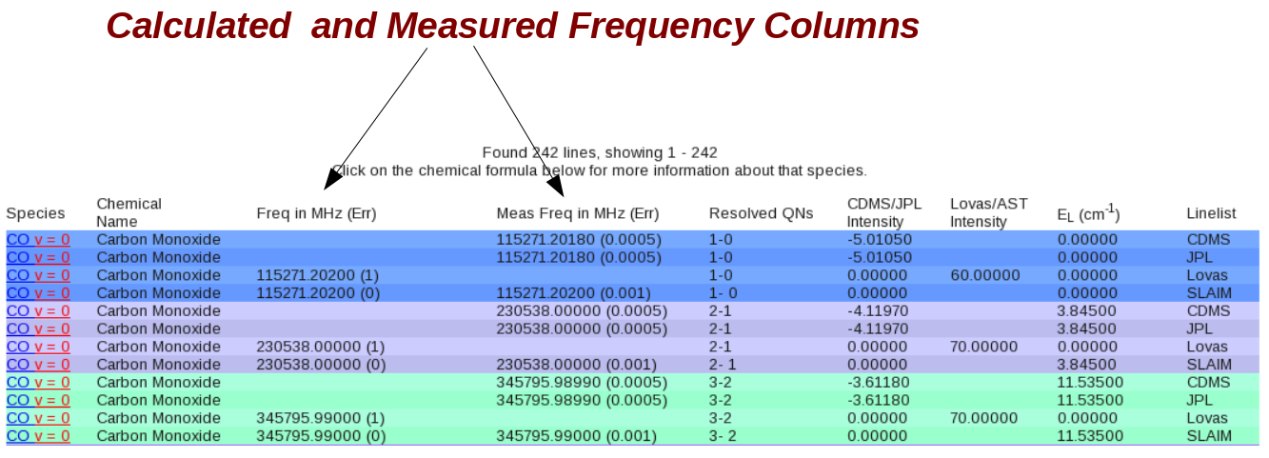
Figure 1.
The laboratory measured values are given if available (such as with the JPL and CDMS catalogs). Otherwise, the theoretical/calculated values are posted, but not both. In some cases, such as with SLAIM and the LISA lines, both values are posted. The predicted frequency is given and the measured frequency is posted where available. In cases where both frequencies are listed, the user will notice slight differences in the laboratory value and the theoretical/predicted value. It should be noted that for molecules with a well determined Hamiltonian the calculated frequencies are usually considered more accurate than the experimental laboratory measurements. For more information about how the theoretical/calculated frequencies were obtained, users should refer back to the original referenced catalog website. Finally, the data provided by Frank De Lucia's laboratory at The Ohio State University, gives ONLY measured frequencies as measured by his FASST technique. Further information about the data from The Ohio State University can be found on the OSU Splatalogue information page (http://www.cv.nrao.edu/php/splat/OSU_Splat.html).
The LOVAS line list only displays frequencies that have previously observed in space. These are displayed under the "Freq" column. For information about the origin of the observed transitions users should visit: http://www.nist.gov/physlab/data/micro/index.cfm and http://physics.nist.gov/PhysRefData/Micro/Html/sec2.html.
Often, many different line lists contain the same transition of a particular molecular species. The NRAO has assigned a "flag" for the recommended rest frequency for all known interstellar molecules. This flag can be turned on under the "Miscellaneous" section of the left sidebar. You will see a checkbox that says, "Display NRAO Recommended Frequencies". Select that option and search. A "splat" () will appear next to the transition frequency that NRAO recommends (see figure 2). In the case where there is a measured and observed frequency for a given transition, refer to the paragraph above but in general, the calculated frequency is often the best one to use.
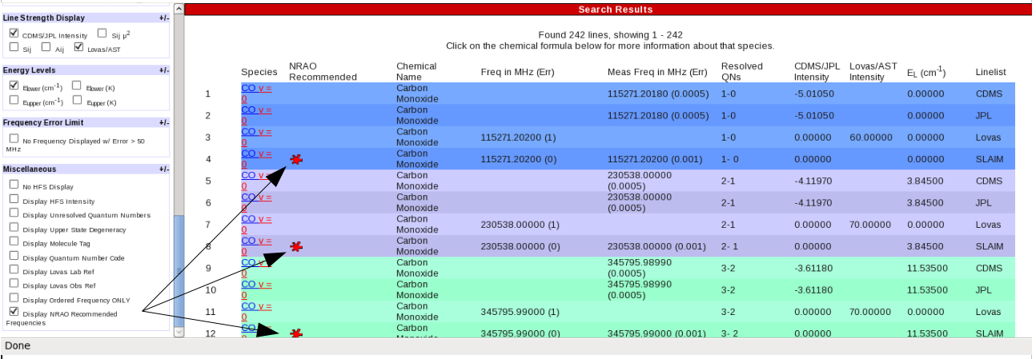
Figure 2.
The decision of which line list and which frequency should be recommended is as follows:
- ONLY known interstellar molecules have been given a recommended rest frequency. This is following the "Lovas Recommended Rest Frequencies" lists published in the Journal of Molecular Spectroscopy Reference Data.
- The most recent catalog entry is typically used.
- The choice is subject to consideration of how close the measured frequency is to the predicted one. If the prediction is "too far" away from the last measured frequency, the frequency is not included. The definition of "too far" was molecule dependent and the users should consult the original references for the laboratory observations.
- In general, frequencies with errors larger than 10's of MHz (of course, depending on the actual rest frequency of the transition) were not recommended. Again, the users should consult the original laboratory references for the errors involved with the experimental setup.
5. Quantum number Format and Reconciliation scheme

The Table available at http://www.cv.nrao.edu/php/splat/QuantumCode.html provides examples of how the quantum numbers were resolved based on the "rules" that have been defined by JPL and CDMS. In general, while many of the examples provided describe how the quantum numbers were translated, many of the molecular species contained in this database and others do not follow any exact rule for interpreting the transition. If there are questions on the translation, the user should refer back to the original reference of the molecule. All the references for each species contained in Splatalogue can be found by clicking on the molecular species of interest in the display list. See figure below:
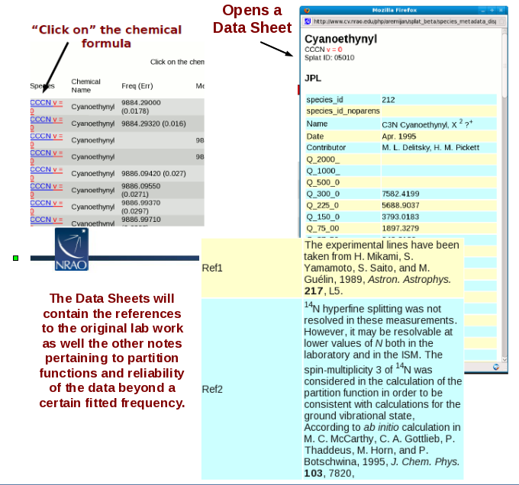

6. Version control scheme

Many of the online databases update a particular molecular species when either new laboratory measurements become available or a better fit to the existing data is possible. This is recorded in a species id version number. However, access to the previous version is often problematic because the old data are removed from the server at the time of the update. This presents a problem to both new users of the catalog as previously reported transitions may now be lost from the database as well as those following up reported transitions from the literature.

In Splatalogue, data are not deleted when an update is made available. Rather the updated data are flagged as a new version in the database. Therefore, a user of Splatalogue will be able to revert back to a previous version of a molecular species and directly compare the versions. As always, we will make a recommendation on which transition frequencies to use but the user will be able to access all the available data as they see fit.

The interface will be subject to version control, with each release undergoing a regression test prior to being made publicly available.

7. Release schedule

The data in Splatalogue and the other online databases will constantly be changing as a result of new fits from existing data or new experimental data become available. As such, it is imperative that Splatalogue have a release schedule that is current enough so the user is confident that they are receiving the most up to date data available. Over the past several years, the rate at which major updates are added to the existing online databases is approximately quarterly. That is, new molecular species or updated fits for an existing species appear every 3-4 months on these databases. In the literature, new fits to existing molecules occur once every 2-5 years (this is very molecule dependent however.)

Given the rate at which the data are coming from the laboratories, we anticipate an annual release and update of the database to account for any edits, changes or corrections that may take place in one of these online sources of data. In addition, an annual update to the database after our colleagues that will only use Splatalogue to disseminate their data have presented laboratory data in the literature is more than adequate given the rate at which these data appear in the literature. The OT and CASA offline databases will also be updated on this schedule.

Finally, additions, subtractions or edits to the Splatalogue homepage have been taking place on an “as needed” basis given individual user requests. This format will change also to a yearly release. Individual updates or changes that are requested by the user community will be compiled via a community forum. This “Splatalogue forum” will also contain many of the “tools and tips” provided by the community on how to best use Splatalogue for their individual science goals as well as a FAQ page where uses can get answers to the most common questions. In addition, a Splatalogue helpdesk and knowledgebase will be available through the NRAO and ALMA User Portals. This system will allow users to submit questions and problems they find while using the Splatalogue homepage or SLAP interface (section 11 below) as well as request new additions to Splatalogue. These requests and bug reports will be compiled and then incorporated into the annual release.

For minor changes and bugs affecting performance or search capabilities, the Splatalogue homepage will be updated with “patches” over the course of a year depending on the severity of the problem found and the time needed for repair. If necessary, in the most extreme cases, functionality may be removed if the repair will take more than 72 hours to diagnose and complete. However, we anticipate this happening only in rare cases.

8. Regression testing

Before each release or each patch is submitted online to the main Splatalogue homepage or changes are made to the SLAP interface, they will be tested by the Splatalogue manager and other members of the NAASC Data Services Group, User Support Group and the NRAO spectral line management group. These tests will take place off another server so as not to interrupt the normal usage off the www.splatalogue.net homepage. Once the groups have decided the appropriate changes have been made and that all the functionality works properly, that release will then be posted off of the main Splatalogue homepage for general use by the community.

Once changes are made, they will be logged and presented to the community off the Splatalogue “What’s New (Updates and Announcements)” page. Again, because of the versioning capabilities of Splatalogue, users will be able to view the older sets of data. However, users will not be able to revert back to an older version of the webpage or SLAP interface. The only way this will occur is if the updated version is found to have reduced functionality or options that are required/requested by the community. All versions of the Splatalogue homepage are saved and can be reverted at any time but only in the most extreme of circumstances.

9. Management and Oversight (Spectral Line Working groups NRAO/International)

The purpose of this memo is to propose that Splatalogue become the official ALMA spectral line database. As such, NRAO and the NAASC have already committed to the formation of the database and have appointed a Splatalogue task lead inside of the Data Services Group of the NAASC. Currently this lead is:

Anthony Remijan – Assistant Scientist (NRAO) / CSV Liaison (NAASC)

It is anticipated that the task lead for Splatalogue rotate over time as responsibilities for an individual would change over time. However, the task lead should be at least a staff scientist with NRAO. Additional postdoc or scientist effort will also be supplied to help update and maintain the database.

In order to facilitate community input and oversight into Splatalogue, the NAASC has formed an “internal" Spectral Line Management Group in Charlottesville, consisting of Anthony Remijan, Crystal Brogan, Harvey Liszt, Al Wootten and Mark Lacy (ex officio). This management group consists of members of the NAASC User Support Group and Data Services Group. The main purpose of this group is to comment on the current user interfaces to Splatalogue, suggest upgrades and enhancements to searches and exporting options and to provide insight on the offline versions of Splatalogue that will be used for ALMA user tools and applications. They will also comment on the usefulness of the data contained in Splatalogue and suggest additions or subtractions. This management plan is described in NAASC Memo 2010-Sept-001 “Splatalogue Management Plan”.

However, we plan to expand the oversight of the data content in Splatalogue to a wider international community effort who are contributing a bulk of the data to the database and the astronomical community. This International Spectral Line Steering Committee will have the opportunity to consult with the Splatalogue task lead and provide the valuable insight necessary to suggest recommended rest frequencies, provide new laboratory measurements or re-calculate fits on existing molecular line data to be used by the astronomical community.

Many of the possible representatives have already contributed data to the Splatalogue effort and conversations have already started on expanding the group membership as well as publishing a yearly microwave molecular spectroscopy review paper which would be analogous to the HITRAN efforts. The lead of the International Steering committee would be the Splatalogue task lead but the chair of the committee would rotate yearly.

Currently, the international consortium is only in the planning stage but the internal spectral line management group has already been established.

10. Proposed criterion for Offline subsets for OT and CASA and how they will be maintained and updated

Both CASA and the ALMA OT have a very specific charge that they must be usable while “offline”. As such, any spectral line query that accesses Splatalogue must also be able to work while a user is not connected to the internet.

In consultation with OT representatives, it was clear they wanted a subset of the Splatalogue database that can be accessed offline that would contain no more than 30000 individual entries.

It was decided that the most useful catalog for the offline version of the OT was a “Lovas/NIST” type catalog that contained all of the detected astronomical transitions, all of the H, He and C recombination lines and all the atomic transitions. This was sent to the OT group in as a .csv file and was then incorporated into the OT. This list currently contains ~18000 line entries that can be searched on in the offline version of the OT.

CASA wanted a much larger subset of lines to carry along for the offline version. This was deemed necessary because it may be that CASA would not access the online version of Splatalogue.

For details on what part of the Splatalogue databases is used in CASA, see the following website:

https://safe.nrao.edu/wiki/bin/view/ALMA/CASA_Offline_Splat_list

When substantial changes are made to the Lovas/NIST or radio recombination line lists, where “substantial” is to be defined by the Spectral Line Management Group, a new version of the offline data subset will be sent to the ALMA OT working groups.

In addition, the Splatalogue homepage has been built so that a user will be able to export a subset of the data they want for import into CASA. As such, the CASA working group will be able to update their offline version as they see fit simply by exporting the requisite data from the Splatalogue homepage.

Additional edits/additions to the Splatalogue homepage or to the data contained in Splatalogue that will affect the offline versions of the OT or CASA will again be posted off the “What’s New (Updates and Announcements)” page off the Splatalogue homepage as well as communicated directly to the project scientists of CASA and the OT by the Splatalogue task lead.

11. Virtual Astronomical Observatory (VAO) Interface
One of the deliverables from NRAO based on several meetings with the astronomical community is that Splatalogue should be Virtual Observatory (VO) compliant, as defined by the International Virtual Observatory (IVOA). As such, we have developed the appropriate interface following the standard VO spectral line access protocols to search the Splatalogue database given a frequency range and some optional filters , i.e. the VO standard SLAP protocol. For more information on the SLAP protocol, visit:
http://www.ivoa.net/Documents/SLAP/
Ray Plante (NCSA and the University of Illinois) from the US Virtual Astronomical Observatory (VAO) has been working with the NRAO on this application to make it as general as possible so that any catalog that has the same database format as Splatalogue can easily implement. We like to call it a "plug-and-play" VO application. This work has been finished and is publically available off a VAO (formerly NVO) site:
http://trac.us-vo.org/project/nvo/wiki/SplataSLAP.
There you can obtain a tarball to configure and install the SLAP service for a Splatalogue like database. The README.txt provides instructions for installation. Also, when one creates a compiled java program, a JAR (Java Archive) file is created that you can run at the command prompt. The WAR (web application archive) file is designed to be run off the web.
Finally, Brian Kent (NRAO) has also generated some code accessing the database via the SLAP protocols with php and IDL. They are available at:
ftp://ftp.cv.nrao.edu/NRAO-staff/bkent/slap/
These are only examples of what can be done accessing a SLAP server. For the Green Bank Telescope, for example, who extensively use IDL as their data reduction software, they can implement what is written there to access line ids, etc.
12. Vision for Future Splatalogue Interaction with other Spectral Line Databases

Given the flexibility of both the database structure of Splatalogue and the SLAP interface, it may be possible in the future that telescope operations and tools will be able to query a general SLAP service and all catalogs that contain a Splatalogue-type database will be accessible to that tool.

We have made that option available to the laboratory astrophysics community by providing both the SLAP interface and Splatalogue database structure. If these laboratories chose to use these structures, all ALMA tools will be able to access their database.

In addition, it is anticipated that Splatalogue will become the microwave equivalent of the HITRAN database. Official ALMA support of the effort will go a long way as well as the establishment of the International Steering Committee. It is our plans to have such a steering committee established by the end of 2011.

