DV08 Focus dependence on Temperatures
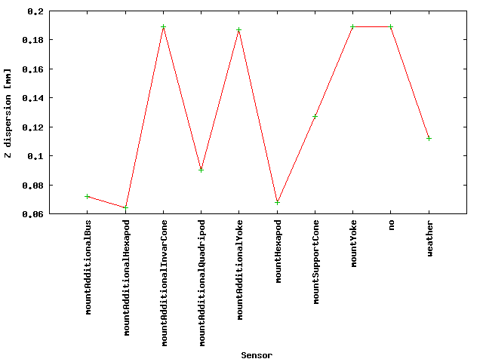
Using 24hrs interferometric focus observations at AOS in Band 7 (Z axis), the best sensors to determinate the focus curves for DV08 are located at Hexapod and at Bus, considering a linear temperature dependence.
Figure 1 shows the Z axis dispersion for the fits using different sensors. Also, it is included a fit with no dependence on temperature (indicated with "no"). The worst sensors to estimate the focus curve are those located at Invar Cone and Yoke, and these results are similar to that using no dependence on temperature. Using weather station measurements, the result is similar to those using sensors at Support Cone and at Quadripods.

Figures 2-11 show the fits using the different sensors. From left to right, Focus versus elevation, Focus residual versus elevation, Focus versus temperature, and Focus residual versus temperature.
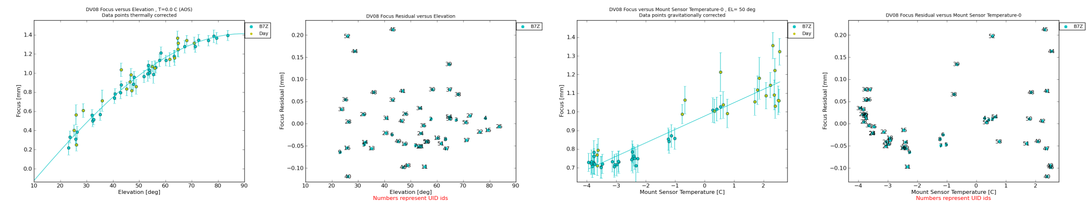
*Figure 2: Fit using Hexapod sensors*
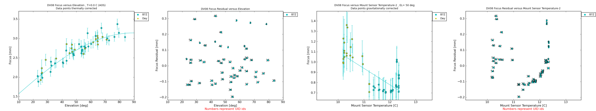
*Figure 3: Fit using Support Cone sensors*
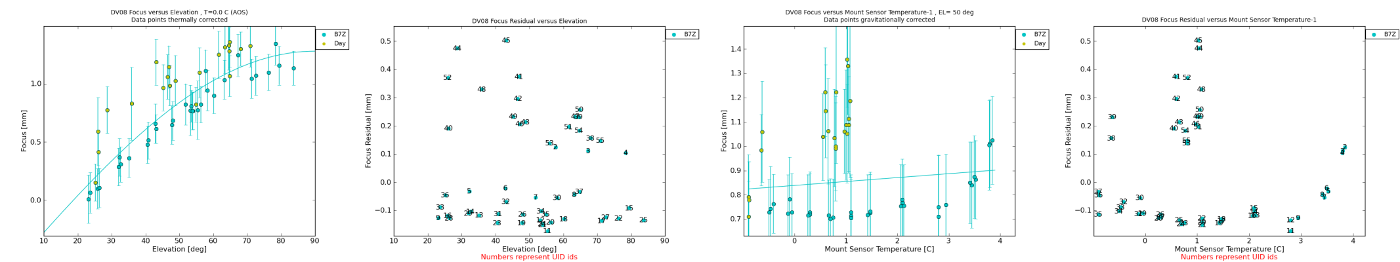
*Figure 4: Fit using Yoke sensors*
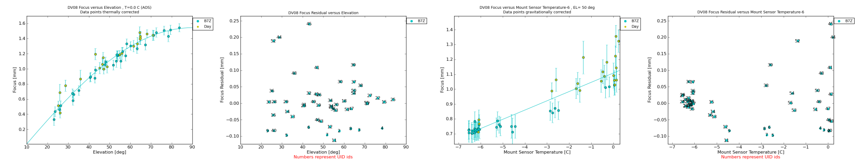
*Figure 5: Fit using Bus sensors*
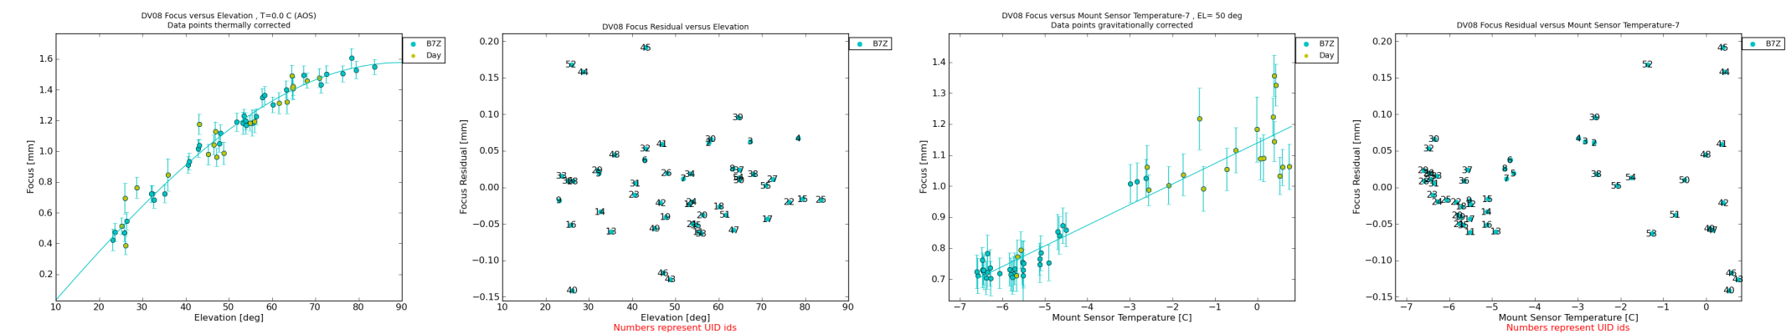
*Figure 6: Fit using additional Hexapod sensors*
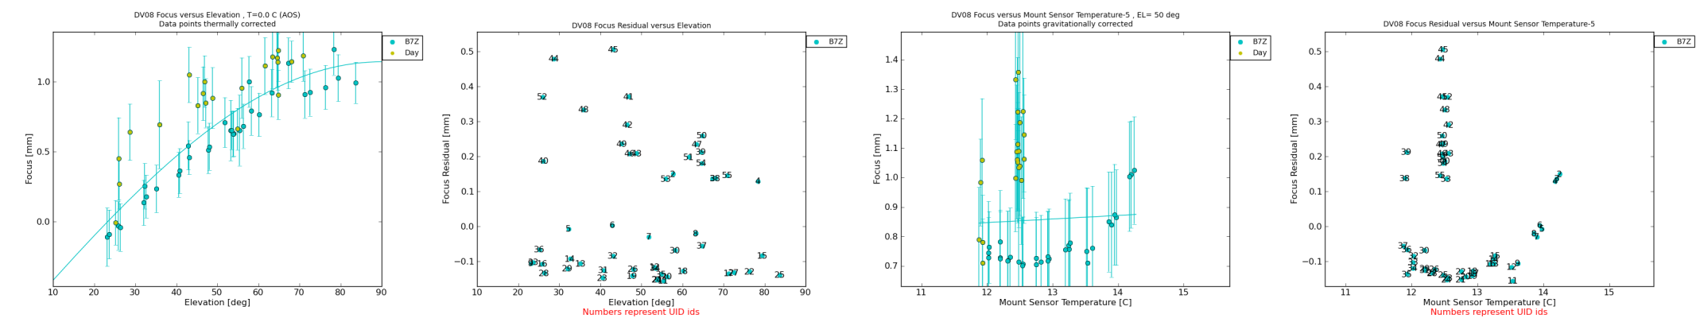
*Figure 7: Fit using additional Invar Cone sensors*
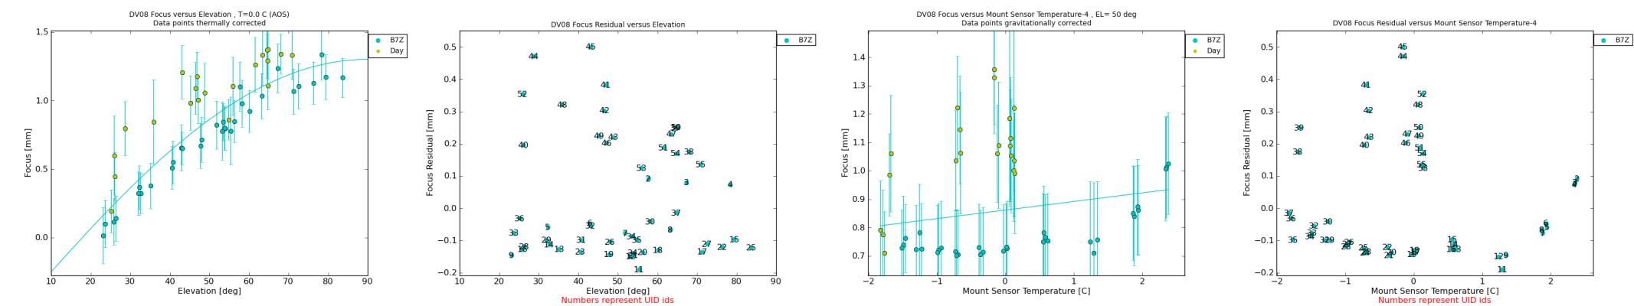
*Figure 8: Fit using additional Yoke sensors*
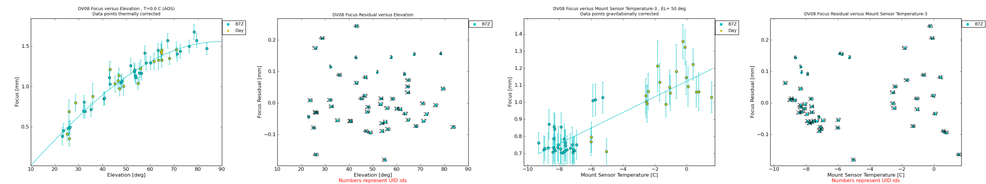
*Figure 9: Fit using Quadripod sensors*
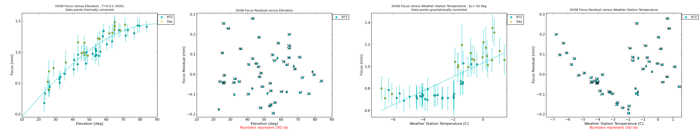
*Figure 10: Fit using AOS Weather Stations*
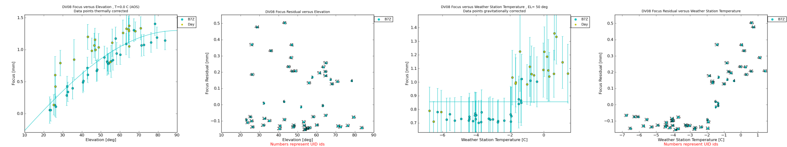
*Figure 11: Fit with no dependence on temperature*
Notes by REH.
These last two plots show that, for this data set at least, the linear dependence on the weather station is a poor fit – there is instead almost a bimodal behaviour in the data – one value of focus when the temperature is below -2 C and a higher value (with more scatter) when it is above -2.
Another thing that is interesting is that the fit to the “additional” hexapod sensors (fig 6) is slightly better than to the “production” hexapod sensors (fig 2) and it seems that the additional sensors show a wider temperature range than the production ones do, going down to -6.5C compared to -4C. I wonder why this is? I see that the Bus temperature also goes down to the lower temperatures but the fit isn’t quite as good.
We do not have the additional sensors or the bus sensors on the other antennas so the conclusion from this data seems to be that it is the hexapod sensors that we should be using in general for making the focus corrections.

