## Advanced Multibeam Spectrometer for the GBT – Project Description

## Instrument Location

The spectrometer discussed in this proposal will be located at the National Radio Astronomy Observatory’s Robert C. Byrd Green Bank Telescope in Green Bank, West Virginia.

## Research Activities to be Enabled

### Research Description

The Robert C. Byrd Green Bank Telescope (GBT) is the premiere single-dish radio telescope operating at centimeter and millimeter wavelengths. It is the largest fully-steerable single dish radio telescope in the world, and is being used for unique experiments over a broad range of science. Its unblocked aperture gives it the sensitivity of a much larger antenna, a high dynamic range, and flat spectral baselines. It has very high sensitivity to low surface brightness emission. The GBT is unique among 100-meter class radio telescopes in that it operates efficiently at wavelengths as short as 3mm.

The GBT is currently hampered in its ability to provide the best possible science to the community due to limitations of the existing GBT spectrometer. The existing data transmission system supports eight individual channels (single-polarization beams) and an 8 GHz bandwidth. However, the GBT’s current spectrometer, used by roughly 70% of the observing projects on the telescope, has a maximum bandwidth of 800 MHz, a 3-level sampling system, and a minimum integration time of more than one second. The result of these limitations is that many experiments either cannot be done with the GBT, or can be done only in an extremely limited fashion. As an example, observations of broad, weak emission lines produced in strong continuum sources require a very high dynamic range for detection. These lines include the Hydrogen 2p-2s fine-structure lines expected to be seen in bright HII regions and planetary nebulae as well as the positronium line expected to be observed in the Galactic Center. The GBT is the first telescope with the necessary bandwidths and sensitivity to provide a reasonable chance at detecting these weak, broad emission lines. However, the current spectrometer’s 3-level samplers severely limit the input dynamic range of these observations, resulting in residual baseline structures in the data. The strong continuum sources can be about 3 times brighter than the system temperature of the GBT, pushing the spectrometer to its limits.

We propose to build a spectrometer that addresses all of the weaknesses of the current spectrometer and is more closely matched to the capabilities of the GBT's front-end receivers. The spectrometer proposed here will support twice the number of signal inputs, sixteen times the number of spectral channels, and nearly four times the instantaneous bandwidth of the existing spectrometer, substantially expanding the science achievable with the GBT's current receivers. The new spectrometer is also a key part of the NRAO’s vision to expand the GBT's science capability with multi-pixel Focal Plane Arrays (FPAs). The first step in the camera development effort has been taken with a project to build a 7-pixel dual-polarization heterodyne feed horn array, the K-Band FPA, which will operate in the 18 GHz to 26 GHz range. The KFPA is under development and will be commissioned on the GBT in 2010. The development and commissioning of the K-Band FPA will be followed by development of a 16-pixel single-polarization array operating at 3mm wavelengths (approximately 100 GHz). The spectrometer proposed here is synergistic with the multi-pixel FPA program, and will open up larger bandwidths, provide more channels, and allow for full use of the 7 dual-polarization KFPA pixels as well as the 16 single-polarization 3mm receiver pixels.

Development of a new spectrometer for the GBT will open a wide range of science applications currently unavailable to GBT observers. The effort will enable a broad range of scientific experiments including those key areas addressed below, including:

***(a) Chemical Bonds in Interstellar Space.*** The chemical processes in the interstellar medium produce a rich set of organic molecules, exotic molecular species, and “pre-biotic” molecules that are relevant to understanding the origin of life on earth. For several decades, molecules have been used as probes of interstellar processes, transforming our understanding of star formation and evolution, and the physical conditions in molecular clouds. A new trend in the chemistry community is to use the unique conditions found within interstellar clouds to inform our understanding of chemistry. The GBT has been instrumental in studying the chemical species outside our atmosphere, playing a key role in developing our understanding of the production and origin of complex organic molecules, a key building block to life. However, two factors remain to limit the usefulness of the GBT in these studies: first, the lines of interest are often separated by many 10s-100s of MHz, significantly farther apart than the existing system can image at the necessary spectral resolution; second, molecular lines are weak and often lie within extended sources, requiring a wide-field imaging system at both low (18-26 GHz) and high (60-110 GHz) frequencies. The FPA systems under development to address this will require the proposed spectrometer’s instantaneous bandwidth, spectral resolution, and multi-feed support.

***Figure 3. Molecular emission maps of comet Hale-Bopp made in HCN (left) and HCO+ (right) with the 14 telescope of the FCRAO whose angular resolution is about the size of the cross in the right panel. Overlaid dots show the footprint of a 16-pixel GBT array in these lines. Figure courtesy A.J. Lovell.***

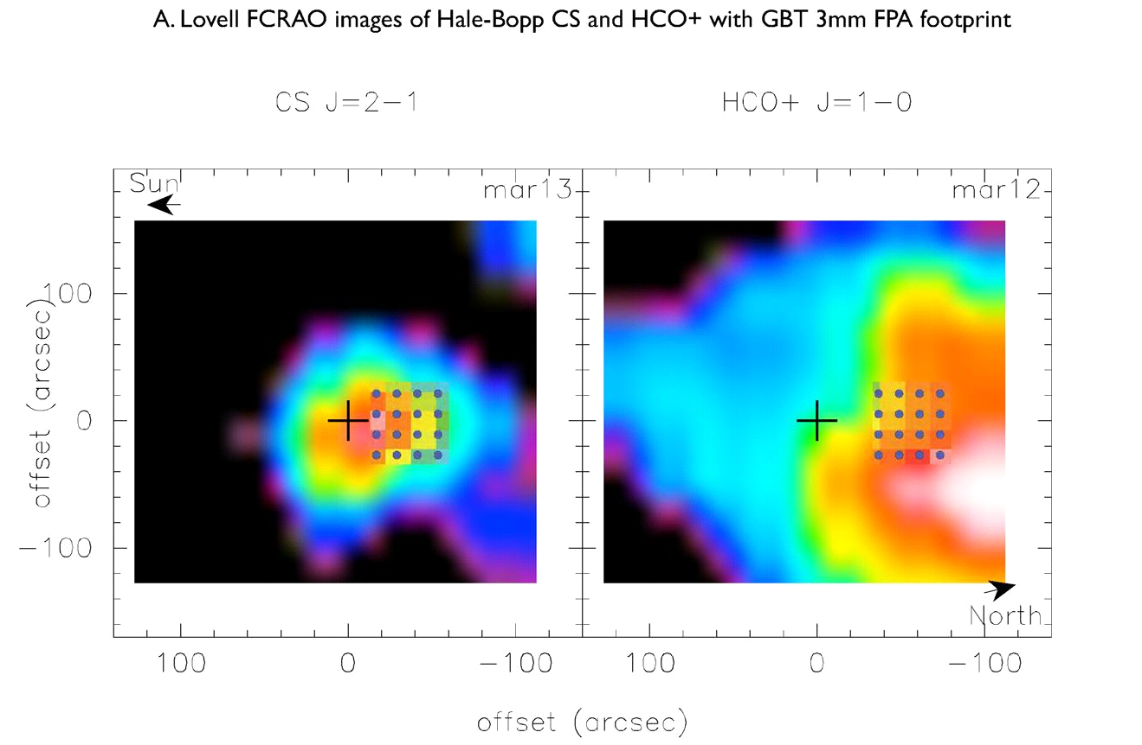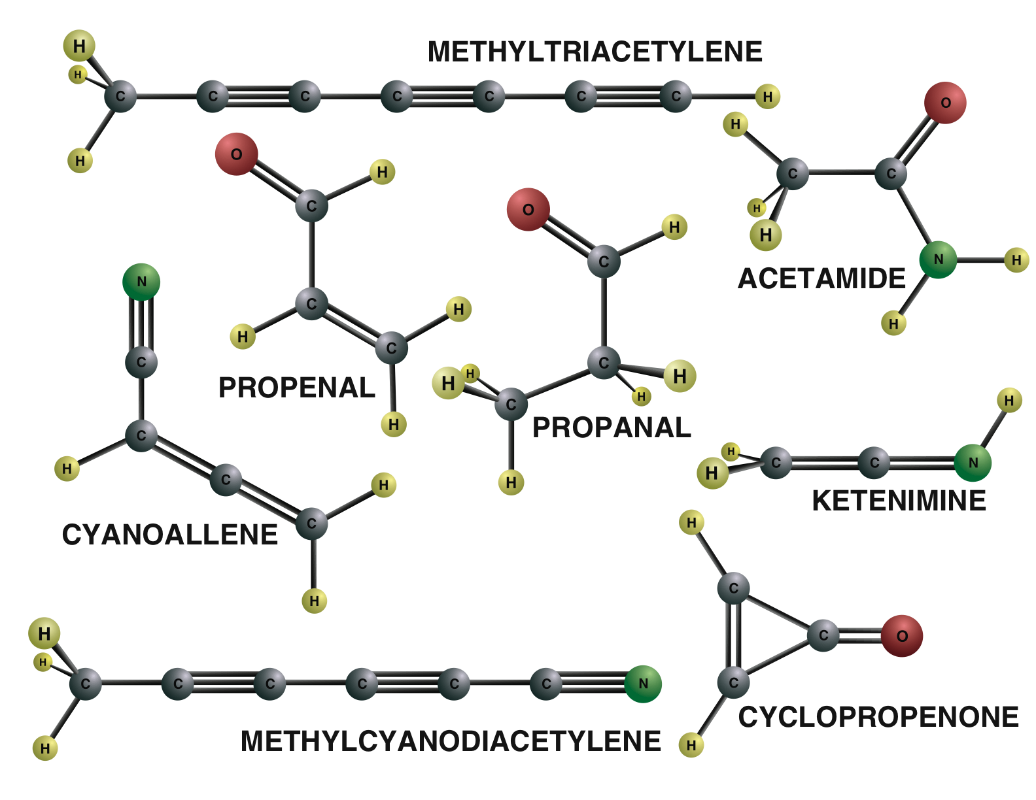

***(b) Are the Fundamental Constants Constant?*** Most physical theories that move beyond the standard model of particle physics predict that the lower energy fundamental constants are dynamic and have likely changed over cosmological timescales. Looking for changes in these constants provides a fundamental test for the theories. Astronomical spectroscopy is the best method for testing the constancy of a number of these low energy constants, including the electron/proton mass ratio, the fine structure constant, and the proton gyromagnetic ratio9. Current studies of the fundamental constants with the GBT and other radio telescopes is severely hampered by radio frequency interference (RFI) within the spectral bands of interest. The proposed spectrometer, with its high input dynamic range and time resolution, will prevent inaccuracies in intensity measurements that occur as a result of strong RFI and will allow for the accurate excision of much of the RFI after digitization.

***Figure 2. Eight new biologically significant molecules were discovered in the interstellar medium in a two-year period using the GBT.***

***(c) Comets: Relics of Solar System Formation.*** Comets are the remnants of material from the coldest part of our solar system. Comet impacts have played a major role in the formation and history of the Earth and in the evolution of its plant and animal species. The study of comets can add significantly to our understanding of the formation and evolution of the Solar System and the Earth. Comets are transitory by nature, and their study requires an instrument such as a 3mm focal plane array, coupled with the proposed spectrometer, that can make rapid measurements of multiple lines simultaneously with high angular resolution over a wide field of view and which has high sensitivity to low surface-brightness lines.

***(d) How Are Stars Assembled?*** How stars are assembled from the interstellar medium and how their masses are determined remain among the major unsolved issues in modern astrophysics. The Studies of the masses and dynamics of molecular cores using temperature and density measurements obtained through observations of the NH3 and CS molecules will provide important information about the dynamics of star-forming regions. Survey speed is a limiting factor in these observations. FPA technology provides almost an order of magnitude increase in efficiency, allowing a large number of cores in nearby star-forming regions to be studied. The current GBT spectrometer will not be capable of supporting the wide-bandwidth FPAs under development; the proposed spectrometer will be required to harness the scientific potential of these new multi-pixel receivers.

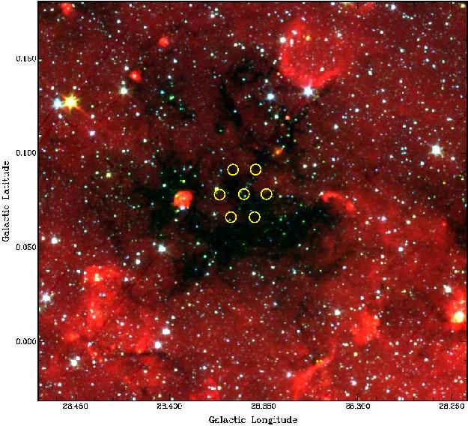

***Community Access and Outreach.*** The proposed spectrometer will be incorporated into the GBT system in accordance with NRAO's “open skies” policy that allows any scientist in the world to apply for, and receive, observing time on the telescope through a peer-reviewed process. A typical year has over 7,000 hours of time available on the telescope for scientific research, with the time each year used on average by more than 400 individual observers representing approximately 150 different institutions. Roughly 20% of the observers using the GBT in an average year are students, some of whom are partially funded through the NRAO for their research. The distribution of observers on the GBT is equally divided between graduate students, post-doctoral fellows, and senior personnel, with a small fraction of the time being awarded for undergraduate research tasks. The NRAO also engages in a number of educational activities including a bi-annual summer school on single-dish radio astronomy for students and professionals, numerous other professional training workshops, and a wide variety of student research and training programs.

***Collaboration.*** The partners for this proposed effort, U.C. Berkeley, CASPER, and NRAO, have worked in a successful collaboration for the past three years using reconfigurable hardware computing platforms and software tools that allow rapid design, verification, and deployment of astronomical signal processing systems. The first area explored by this collaboration was the use of FPGA technology to build a flexible signal processing system for the detection and timing of pulsars – highly magnetized, rapidly spinning neutron stars. The study of pulsars, which probes physical laws at the most extreme conditions known, requires precise timing, wide instantaneous bandwidths, and the ability to disentangle the signal of the pulsar from environmental effects. The result of this effort is the Green Bank Ultimate Pulsar Processing Instrument (GUPPI). GUPPI has been highly successful, and was released in September of 2009 for use on the GBT by all observers.

### Personnel

This project will be staffed by experienced UC Berkeley and NRAO personnel, as well as graduate and undergraduate students. This section is now N/A until the project is sorted out.

## Description of Research Instrumentation and Needs

### Instrument Development, Rationale, Design, and Methods

Building on their successful collaboration on the GUPPI project, UC Berkeley and NRAO now propose to use similar technology to develop a spectrometer with 1.350 GHz of bandwidth, 16 Intermediate Frequency (IF) inputs, and X spectral channels per IF, divided into N “zoom” windows, or sub-bands, per IF, where N is ~four. These sub-bands will allow efficient use of the 32k channels for studies of multiple lines that lie in the instantaneous 1.350 GHz of bandwidth. This bandwidth and number of channels is closely coupled to both the 7-pixel dual- polarization 18-26 GHZ receiver (K-Band FPA) project and the proposed prototype 16-pixel single-polarization 3mm FPA. Developing the proposed spectrometer will allow the maximum value to be extracted from the science observations conducted with these new receivers. Existing GBT receivers will also benefit from the advanced capabilities of this new instrument, as they are also limited by the currently available spectrometer.

In addition to the increased capability provided to the GBT’s observers, additional modules will be developed and added to CASPER’s open-source FPGA digital signal processing (DSP) toolset 8, allowing future spectrometers to be built with correspondingly less effort.

The technical approach used will be to treat each dual-polarization intermediate-frequency (IF) input as an independent full-Stokes spectrometer, allowing cross-correlation between the pair of IFs. The independent spectrometers will be coordinated such that they can be used as a single 16-input spectrometer, or as an 8-pixel, dual-polarization spectrometer. Tradeoffs between the number of active sections and data rates will be possible with this design, allowing astronomers to tailor the instrument to the science requirements. For example, pulsar astronomers could elect to use only one or two pairs of inputs, and use a correspondingly higher dump rate for high-resolution timing studies. **Figure 6** below illustrates the overall design of the spectrometer system.

The IF signal arrives at the spectrometer’s Front-end Electronics (**Figure 7**), which conditions, filters, and feeds the IF into signals feeding the analog-to-digital converters (ADC’s) in each path. These converters digitize the signal and feed it to a Reconfigurable Open Architecture Computing Hardware (ROACH) board. The FPGA on the ROACH board will accomplish the digital processing (mixing, sub-banding, and spectral analysis) on the IF signal, and will route the data to the Signal Combining and Accumulator board. This board combines the signals from both polarizations, and accumulates the results in on-board accumulators.

The accumulated spectra are sent via dual 10 Gb/second Ethernet links to the Ethernet switch, where it is sent via optical fiber to the Green Bank Observatory Jansky Lab Equipment Room. When the optical signal is received in the Equipment Room, it is routed through another Ethernet switch to a pipeline processor. This pipeline processor applies the data calibration pipeline to the raw data, and prepares it for the astronomer. The pipeline processed data is written out to the disk subsystem (**Figure 6**), where it is available for post-processing analysis by existing Green Bank computing facilities.



*Figure 6. Spectrometer system block diagram.*

Front-end Electronics



*Figure 7. Front-end electronics*

The front-end electronics contain the analog components that will be needed to match the GBT IF system with the spectrometer’s interleaved ADC’s. A 3-Gs/s ADC chip will be used to digitize the IF signal at 3 GS/s. The front-end electronics will filter and amplify the signal for best performance of the ADC’s. This subsystem will be developed for the project by the engineers at NRAO. The design will be released to the community for use in subsequent systems through the archive maintained by the CASPER project. **Figure 7** is a block diagram of the front-end electronics.

Analog to Digital Conversion

The signal from the front-end electronics will be fed to the 3 GS/s analog to digital converter (ADC) boards hosted on each ROACH board. These ADC boards are an off-the-shelf design using a National Semiconductor ADC083000 A/D converter chip. A picture of this board is shown in **Figure 8.**

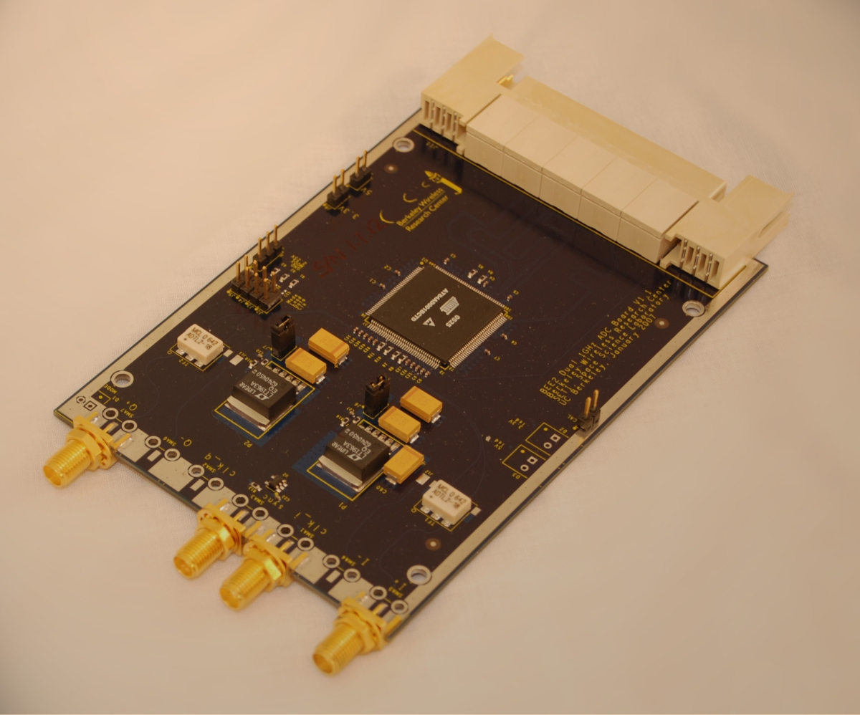

*Figure 8. National Semiconductor ADC083000 board*

Signal Processing Hardware

The pair of ADC’s will feed a ROACH or ROACH-II board, which was designed by a consortium of Radio Astronomy groups: CASPER, NRAO, and the MeerKAT project in South Africa. A Power PC and a Xilinx Virtex-5 (Virtex-6 in ROACH-II) FPGA provide computing power. The signal processing boards will feed their results into a signal combiner/accumulator board, for further processing, accumulation, formatting, and transmission to the Pipeline Processor and Spectrometer Data Storage Subsystem. A prototype ROACH board is shown in **Figure 9**.

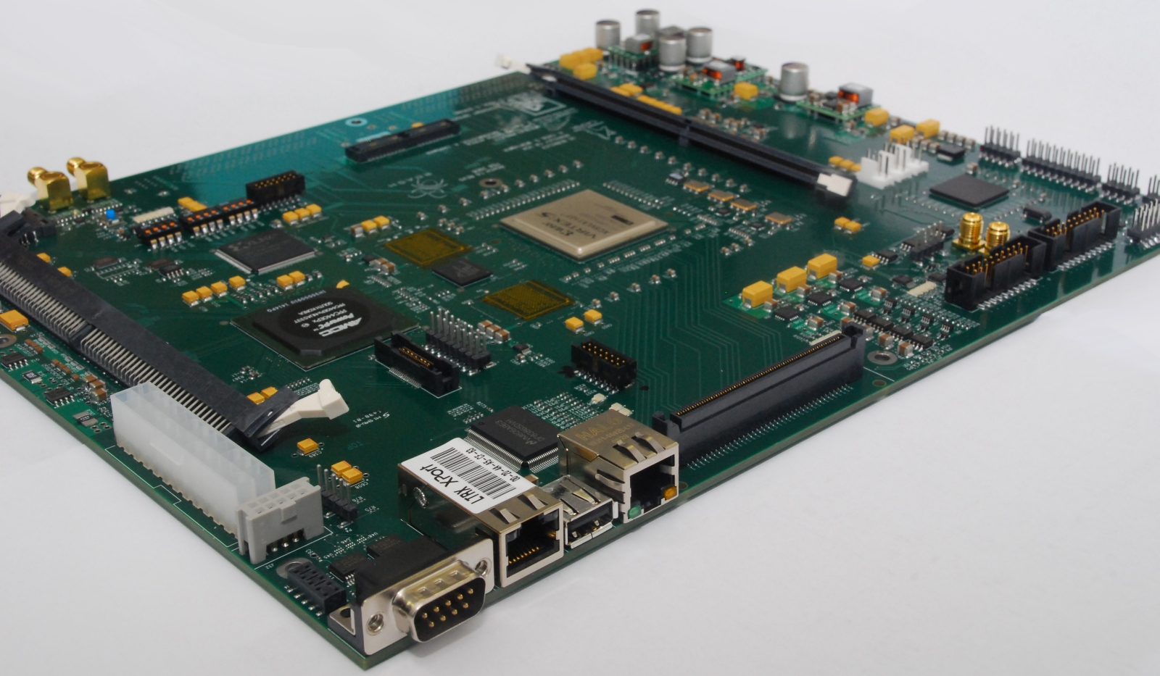

*Figure 9. Reconfigurable Open Architecture Computing Hardware (ROACH) board*

Pipeline Processor and Data Storage Subsystem

The Pipeline Processor **(Figure 10**) is an integral part of the spectrometer. The final DSP functions, long-term accumulation, averaging, and calibration are performed in standard computer hardware. This hybrid approach of combining custom DSP hardware with off-the-shelf processors lowers the cost of the complete system, and makes the entire system more versatile and flexible.

The Data Storage Subsystem is optimized for large sequential block writes, allowing the spectrometer to output its data at up to 500 MB/second, sustained. The architecture of this data storage uses standard high performance disk subsystems, and an open-source cluster file system which allows virtually unlimited expansion of the disk space. The data storage subsystem is designed so that astronomers can access the data from previous experiments while new data is being acquired. The data storage subsystem will be connected to the existing Green Bank computing infrastructure through the 10 Gb Ethernet switch.



*Figure 10. Pipeline Processor and Spectrometer Data Storage subsystem.*

Signal Processing Gateware

The signal processing pipeline internal to the FPGA processors employed in this spectrometer architecture will be designed by engineers and students at UC Berkeley and Green Bank, using the tools developed by the CASPER project, under the guidance of Werthimer and Parsons. Much of the signal processing gateware that will be used already exists in the CASPER project’s libraries, but new modules for the proposed spectrometer will be developed and released to the community via the CASPER archive.

One such module will implement the sub-banding, or “zoom” feature, that will allow astronomers to choose several narrow windows to observe simultaneously. The 32K available channels will be divided across the total bandwidth of these narrower windows, thereby allowing small windows of high resolution spectroscopy across a wide bandwidth.

Other modules to be developed are the Packetized Polyphase Filter Bank and Packetized Fast Fourier Transform. These modules are useful for the case where the digitizing subsystem is unable to process all the data on board, and the data must be communicated to other boards for filtering and transforming. These modules will be derived from the Streaming Polyphase Filter Bank and Streaming Fast Fourier Transform that are already in the CASPER library, which were developed under the guidance of Werthimer and Parsons5,6,7,8.

Control, Data Collection, and Pipeline Processing Software

NRAO will provide personnel familiar with the GBT control system to build the control software for the spectrometer. Since it is a fundamental goal of this project to provide an instrument that is immediately supported and offered to all astronomers using the GBT, it is essential that the instrument be developed to fit in and work well with the GBT control systems and user interfaces.

The data collection software will be adapted from existing projects. NRAO has recently finished building a fast pulsar machine (GUPPI) which used the CASPER architecture, and which can provide a base of software.

An online Data Processing Pipeline is being developed for use with the new GBT KFPA receiver and the existing GBT spectrometer and can be adapted for use with the new spectrometer. This data processing pipeline software will be provided by NRAO at no cost to the project, and will be adapted and integrated by the project team.

### Instrument Utility, Enhanced Performance

The table in **Figure 11**, below, summarizes the characteristics of the existing GBT spectrometer and the proposed spectrometer, and shows how this new instrument will enhance the performance capabilities of the GBT. The new spectrometer will have enough high dynamic range (8 bit) IF channels to service all IF ports of the currently planned focal plane array receivers. It will have more than three times the bandwidth of the existing spectrometer. Its X spectral channels are a factor of Y greater than the 2048 channels available in the high speed sampler mode of the GBT spectrometer. The new sub-banding technology will result in more efficient use of the spectral channels by using them to examine areas of interest, instead of allocating them evenly across the band. The peak disk bandwidth of 500 MB/second is a factor of 40 greater. These improvements add up to a tremendous increase in the science capabilities of the GBT.

|  |  |  |  |  |  |  |  |
| --- | --- | --- | --- | --- | --- | --- | --- |
| **Instrument** | **IF Ports** | **Spectral Channels** | **Bandwidth** | **Number of ADC bits** | **Sub-bands** | **Peak Disk Bandwidth** | **Dump Rate** |
| GBT Spectrometer | 8 | 2048 | 800 MHz | 1.5 | 1 | 12 MB/sec | 1 Hz |
| Proposed Spectrometer | 16 | X | 1.350 GHz | 8 | N | 500 | > 1KHz |

***Figure 11. Table comparing the characteristics of the current GBT spectrometer with the enhanced capabilities of the proposed instrument.***

### Instrument Necessity and Adequacy

The GBT needs a new spectrometer that matches the capabilities of its complement of front-end receivers. Even before the new FPA initiatives were started, the GBT Spectrometer was a limiting factor in many experiments. The proposed effort presents the opportunity to build a new spectral line backend that can be used with existing instruments to enhance their productivity, and at the same time support development of the FPA system that is under development for the GBT.

## Impact on Research and Training Infrastructure

### Impact on Research and Organization Goals

Development and installation of the proposed new signal processing system on the GBT will significantly enhance the overall capabilities of the telescope, enabling a broad range of scientific studies with this instrument. GBT observing time is available on a competitive basis to qualified scientists, regardless of institutional or national affiliation, upon evaluation of research proposals on the basis of scientific merit, the capability of the instruments to do the work, and the availability of the telescope during the requested time. In a given year more than 400 individuals, representing at least 150 institutions, typically use the telescope. Most of these projects will benefit from the improved spectrometer.

The GBT is also used for a number of annual and bi-annual training workshops and other training sessions for students and astronomers within the United States. The sessions are aimed at a variety of ages, from high school students through undergraduate students, graduate students, and post-graduate professionals (both teachers and professional research staff). The NRAO is also a participant in the NSF funded *Research Experience for Undergraduates* and *Research Experience for Teachers* programs, which bring roughly 8-10 undergraduate students and 2-4 secondary school teachers to the GBT for 2-3 months each year to learn about and do research in radio astronomy. Additionally, NRAO and the Green Bank site have an active program for both cooperative education and post-graduate internships, hosting anywhere from 2-4 cooperative education and 1-3 internships at given time, typically in the fields of digital and software engineering. When using the GBT for their training, the proposed new instrument will be a major component of the workshops. With its improved capabilities the NRAO will be able to add additional components to the current training opportunities, particularly in the field of radio frequency interference recognition and excision theory and techniques.

Working together, the NRAO and the UC Berkeley staff have put together a successful training program for young engineers and astronomers to design, develop, test, and commission new instruments for the GBT. An excellent example of this program is GUPPI, an FPGA-based signal processing system which is designed for high time resolution imaging using both coherent de-dispersion and incoherent filterbank modes. This program has involved three undergraduate and graduate students from West Virginia University, four undergraduates from the University of Cincinnati, and graduate students from UC Berkeley and Caltech.

### Student Involvement, Education Enhancement

As described in the section above, the new spectrometer will be available for use by astronomers and students who are allocated time on the instrument, as well as to students and professionals during the summer schools and biennial training programs.

A more immediate and compelling impact is on student involvement in the proposed project. The proposal funds three graduate students three undergraduates who will be heavily involved in the planning and execution of the project. Senior engineers and scientists at both NRAO and UC Berkeley will mentor the students, and will ultimately be responsible for the execution of the work and delivery of the proposed spectrometer. At the NRAO site in Green Bank, the proposal funds an undergraduate and a graduate engineering student. These students are supported and mentored by a senior digital engineer, a digital engineer, and a microwave engineer. These engineers have extensive experience in radio astronomy instrumentation, as well as experience working with students. The no-cost post-doc at Berkeley will work with scientists at the NRAO and in the broader astronomical community to ensure that the instrument meets the needs of the community. See Section 9.f for the complete post-doctoral mentoring plan.

In addition to these students directly funded by the proposal, the NRAO works closely with the faculty and students at West Virginia University. These faculty and students will benefit from the larger cooperative group working at Green Bank on this signal processing project. Other groups at Green Bank include a group from Brigham Young University working on RFI excision and beamforming arrays. Funding students and engineers in Green Bank working on digital signal processing for this instrument will indirectly enhance the interaction of the Green Bank staff and these other research groups.

## Management Plan

While the final authority and responsibility for managing the project remain with the UC Berkeley PI Dan Werthimer and his organization, much of the day to day project management structure for this project is being provided by NRAO. This is because the instrument will be hosted at the GBT, and the NRAO’s Green Bank staff is experienced with managing projects like this that require intense coordination between the instrument builder and the GBT staff. One such project is the Zpectrometer project by A. Harris et al 1. NRAO provided RF engineering, Project Management, and Software talent to this collaboration, in much the same way that is envisioned for this proposal. Most problems in collaborations such as this one can be traced to a lack of communication and planning among the partners, and we wish to avoid this by using a tried and true project management scheme.

NRAO has the project management experience and knowledge to successfully manage the collaboration, and leave the technical leaders and scientists free to make their respective contributions. At any given time, Green Bank is involved in multiple simultaneous development projects either as a partner, collaborator, or sole provider. A program office was created with the expressed purpose of managing the creation, funding, contracts and agreements, staffing, and project management of these endeavors. The program office works with the project team to manage the scope, schedule, communications, and operational hand-off of projects. The preferred methodology is to assign a project manager from the team to oversee the daily project issues who is well versed in the technology, applications, and operational considerations of the project. Teamed with the Green Bank program manager, they handle stakeholder communications, set expectations for the project stakeholders, partners, and the development team, plus monitor and manage the project’s risk profile.

Operating under the direction and control of the UC Berkeley PI, the NRAO program office will execute any needed memoranda or agreements with the project partners, work with the UC Berkeley project manager to identify and retain qualified staff and students, manage and report on the overall project schedule, maintain the NRAO project budget, manage external and stakeholder communications, and manage the overall project risks.

The organization chart shown in **Figure 12**, below, shows the relationship between the partners in the project. NRAO personnel are managed by the NRAO Project manager, who reports to the PI, Dan Werthimer, as do the co-investigators. Dan Werthimer has primary responsibility for managing the project, including development of the design of the FPGA Hardware and Gateware, and all other tasks assigned to the personnel in Berkeley. Aaron Parsons is a co-PI in both science and in DSP system development. Research astronomer Eric Korpela will work ensuring the instrument, as it is being designed and built, meets the needs of the astronomy community.

Karen O’Neil and David Frayer are responsible for developing specifications, tests, and commissioning, along with supervising. John Ford has the primary responsibility for the overall system engineering effort, as well as responsibility for all engineering work done at Green Bank. Werthimer is responsible for hiring the student researchers, and ensuring that they are properly mentored and given tasks suited for their abilities and interests. Ford will assist him in this task for the students based in Green Bank.

***Figure 12. Chart showing organization of management responsibilities for the proposed effort***

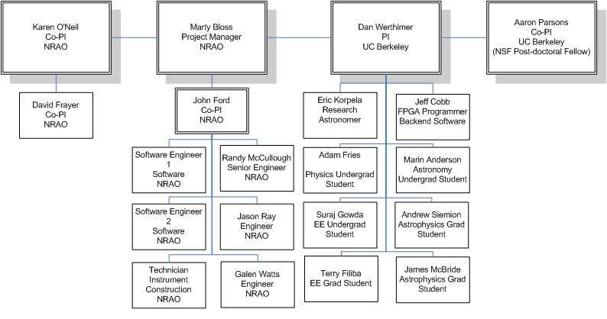

### Instrument Design, Construction, and Commissioning

The work breakdown for this project has been divided into six distinct tasks, each of which will contain many smaller tasks. As noted below, part of the design and development phase is to create a project plan that can be tracked and followed once the major systems decisions are made and work commences.

1. **Design and Development**

During the duration of this task, we will develop and agree on the detailed specifications of the spectrometer, and develop the work plan for the remainder of the project. We will prototype various options for doing the signal processing work, and complete the analysis to ensure a working system. We will develop the interface specifications for the mechanical envelope, including cooling, power, size, and weight. We will develop the software interface documents, and detail the support needed from the GBT observing system. The design and development task will last 9 months, with all disciplines (Electronics, Software, FPGA Programming, Microwave Engineering, and Science) involved.

1. **Detailed Engineering**

During the Detailed Engineering task, we will design the front-end electronics, the power distribution system, racks, cabinets, and other hardware. Mounting brackets, fixtures, and cabling runs will be designed. Space in GBT fiber bundles and circuit breaker panels will be reserved. Orders for materials and supplies will be entered. Test plans for subsystem and system testing will be developed. Most of this work will be done in Green Bank by the undergraduate and graduate engineering students under the direction of Green Bank engineers.

1. **FPGA Programming**

This task will begin concurrently with the Detailed Engineering phase. During this phase, the DSP and FPGA control logic will be developed. Most of this work will be done by the UC Berkeley group engineers and students under the direction of Werthimer and Parsons. . We expect this task to take 12 months.

1. **Software Development**

The software development task will begin with the end of the design and development task. During this task, the Green Bank Software Development Division (SDD) will design and implement the software needed to control the instrument, acquire the data, and integrate the instrument into the GBT observing system. SDD engineers are experienced in writing control software for instrumentation, and have successfully completed control software and system integration for the Zpectrometer, the MUSTANG 64-pixel Bolometer Receiver, the Caltech Continuum Backend, and GUPPI. All four of these projects had requirements similar to this spectrometer project, but were smaller in total scope. We expect this task to take 12 months.

1. **Construction**

Construction will be done at the Green Bank site. All machine work and custom assemblies will be built by the Green Bank shop and electronics technicians. The Project Manager will ensure that sufficient time is reserved in the shop for this effort.

1. **Commissioning**

Commissioning will be accomplished with the instrument post-doc. The instrument post-doc will be supported by O’Neil and Frayer, along with the Green Bank science staff. Engineering and Software will be supporting commissioning as well. The commissioning plan will be developed by the science co-PI’s and the instrument post-doc during the early phases of the project.

The notional timeline in **Figure 13**, below, shows the relationships and relative scheduling of these tasks:

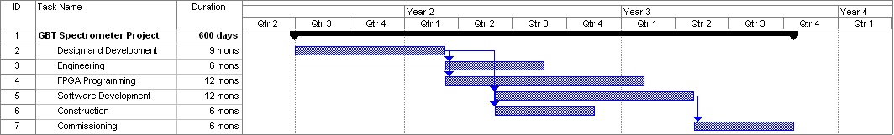

***Figure 13. Notional project timeline for the proposed effort***

### Technical Expertise and Project Staff

Needs redone.

### Risk Mitigation

There are several risk areas that we have considered:

* Radio Frequency Interference generated inside the system
* Designs too large for the FPGA because of additional desired features
* Personnel turnover

These are risks that are familiar to the management team and have been successfully mitigated in other large, cutting-edge development projects. Therefore we are confident that these risks are manageable for this project.

The NRAO in Green Bank is a leader in RFI suppression and RFI-free design practices. Our experience in building and outfitting the GBT has allowed us to build up considerable expertise in what works and what does not. The Green bank team will design and build a custom filtered enclosure for the digital hardware to suppress any noise generated in accordance with the standards required for installation on the GBT.

In designing DSP personalities for the FPGA’s, there is the potential for desired features to outgrow the FPGA resources available. In this case, we can take one of two courses of action. We can trim out features that have caused the design to grow, or we can add hardware to the design. Typically our first approach is to optimize our designs, and if project economics or technology limits present a barrier, trim the features, with guidance from the Science PI’s.

Personnel turnover is always a risk in a multi-year program. We have structured the work so that much of it is done in small modules by students, with an experienced engineer guiding and mentoring them. Turnover is a natural byproduct of the use of students for much of the design work, so succession is built into the project plan. The senior personnel at Green Bank and at UC Berkeley are being assigned to this project at less than full time, encouraging knowledge sharing across the partnership. Although the loss of any personnel is a risk to schedule, the broad understanding at each organization ensures a continuity of knowledge.

### Instrument Design Availability

This project will be included in the online archive of projects that the CASPER project maintains for developments using CASPER hardware and software. Materials to be provided to the archive include the hardware design, the software design, software implementation, and all project documentation. Assistance from NRAO and CASPER personnel will be provided to help others in the research community implement a copy of the design for other research facilities.