Prepared By:
Name(s) and Signature(s) | Organization | Date
- Remijan | NRAO/NAASC | 2011-07-28
Approved By:
Name and Signature | Organization | Date
Released By:
Name and Signature | Organization | Date

Change Record

Version | Date | Draft # | Reason/Initiation/Remarks
A | 2011-08-08 | 2.4 | Working draft – AJR sends to WG and Triage staff for review and comment.
A | 2011-09-20 | 2.5 | Revision by J. Crossley and A. Hale. Incorporating comments from J. Hibbard and A. Remijan.
A | 2012-07-23 | 2.6 | Revision by A. Hale. Updated section 4.3 and Section 3
A | 2013-06-02 | 2.7 | Revision by A. Crossley.

Table of Contents

1 Supporting Material 5
1.1 Acronyms 5
1.2 Related Documents 6
2 Introduction and Concepts 7
2.1 User and Staff Roles 7
2.2 Staff Roles 8
2.2.1 Triage Role 8
2.2.2 USS Role 9
2.2.3 Manager Role 9
2.3 Ticket life-cycle 9
2.3.1 Open 9
2.3.2 Pending 10
2.3.3 Resolved 10
2.3.4 Response Overdue 11
2.3.5 Closed 11
3 ALMA Helpdesk Departments 12
3.1 Proposal Submission Emergency Department 13
4 Knowledgebase Articles 13
5 Reports and Ticket Tracking 14
6 Ticket Servicing Rules 15
7 Staff interface details 18
7.1 Staff view: logging in 18
7.2 “Home” Tab 19
7.3 Notifications 20
7.4 “Tickets” Tab 21
7.4.1 Viewing Tickets 21
7.4.2 Ticket Filters 23
7.4.3 Ticket Search 25
8 User Support Specialist (USS) 26
8.1 Standard Helpdesk Tasks 26
8.1.1 Examining a Ticket 26
8.1.2 Posting a Reply to a Ticket 27
8.1.3 Changing the Status of a Ticket 28
8.1.4 Adding Notes to a Ticket 28
8.2 Adding a Knowledgebase Article 30
8.3 USS Procedure for Responding to Tickets 31
8.4 Ethics in USS Support 32
8.5 Management 32
9 Getting Input From Other Parts of the Project 32
9.1 Transfer of Tickets Between ARCs 32
9.2 Transfer of Tickets to the Proposal Handling Team 33
9.3 Transfer of Tickets to the Change Request Standing Committee 34
10 Procedures for Responding to tickets – Triage 35
10.1 Examining a Ticket 35
10.1.1 Assigning a Ticket 35
10.2 Changing the Department of a Ticket 37
10.3 Forwarding Tickets 37
10.4 Summary of Triage Workflow 38
A. APPENDIX: Helpdesk User Interface 39
B. APPENDIX: USS Checklist for Answering Helpdesk Tickets 42
C. APPENDIX: Report and Ticket Tracking Screens 43
D. APPENDIX: Software Bug-Reporting Systems 47
SPLATALOGUE 47
SIMOBSERVE and SIMANALYZE 48
Science Operations 48

Supporting Material

Acronyms

ALMA Atacama Large (sub)Millimeter Array
AOP ALMA Operations Plan
ARC ALMA Regional Center
CASA Common Astronomy Software Applications
CRSC Change Request Standing Committee
DSO Department of Science Operations
EA East Asia
ESA European Space Agency
ESO European Organization for Astronomical Research in the Southern Hemisphere
EU Europe
Euro-VO European Virtual Observatory
EVLA Expanded Very Large Array
HST Hubble Space Telescope
IPT Integrated Product Team
JAO Joint ALMA Observatory
JIRA From Wikipedia: “Rather than an acronym, JIRA is a truncation of Gojira (the Japanese name for Godzilla)”
KB Knowledgebase
MOU Memo of Understanding
NRAO National Radio Astronomy Observatory
NA North America
OT Observing Tool
PHT Proposal Handling Team
PI Principal Investigator
SMS Short Message Service
USS User Support Specialist
VAO Virtual Astronomical Observatory

Related Documents

No. | Title | Authors | Version & Date | AEDM ID or document name
 | ALMA Helpdesk: Requirements | Various | Version B0, 2011-07-27 | AEDM# TBD
 | Kayako SupportSuite | Various | V3.6, revision 13 | http://www.kayako.com/manuals/
 | ALMA Phase 2 Procedure Document | Various | TBD | AEDM# TBD
 | Phase II Process and Change Request Procedures (Cycle 0) | Various | A3b, 2011-10-07 | AEDM# TBD

Additional helpdesk documentation can be found at:
https://sites.google.com/site/almacommunityoutreach/arc-workflow-folders/helpdesk-materials

Introduction and Concepts

The Atacama Large Millimeter/submillimeter Array (ALMA) helpdesk provides a mechanism for keeping track of user queries, thus ensuring that queries are answered in a timely and professional manner. The helpdesk also provides a Knowledgebase (KB), which can be used to find answers to common queries without the need to submit a helpdesk ticket and without the user actually logging into the helpdesk system.

The helpdesk software, SupportSuite, is a product of Kayako Infotech Ltd., and is in use in a number of other astronomical environments such as Spitzer, Herschel, European Space Agency (ESA), European Virtual Observatory (Euro-VO) and the National Radio Astronomy Observatory (NRAO). It is highly configurable and customizable, and a detailed description of what is available is given in the Kayako manual. This guide is intended as a reference for ALMA staff, providing an overview of key features of our particular implementation of the Kayako helpdesk.

The helpdesk consists of a single instance of Kayako that contains one “workgroup” for each ALMA Regional Center (ARC). This way, staff at each ARC see only the departments and tickets in their ARC’s workgroup and can also set specific workflow assignments for their workgroups in addition to the overall agreed upon workflow across ARCs. There is a mechanism for transferring tickets between ARCs as well as submitting tickets to the Proposal Handling Team (PHT) and the Change Request Standing Committee (CRSC). It is the goal of the helpdesk to “transfer knowledge and not tickets.” So, the transfer of tickets between ARCs should be done sparingly and be contained to only those tickets that require specialized expertise from a particular User Support Specialist (USS) from another ARC.

User and Staff Roles
Kayako keeps user and staff roles separate. Users access the helpdesk system under the ALMA Science Portal. Staff with responsibility for answering tickets (known as User Support Specialists or USS) will have separate “staff” helpdesk accounts (i.e. accounts separate from the ALMA Science Portal) to log into the helpdesk.

USS should not usually need to submit tickets as users except under special circumstances. To submit a ticket as a user, a staff member would login to the user portal using their ALMA user ID and password (obtained through self-registration on the Science Portal) and click on the “Helpdesk” tab to obtain the user interface to the helpdesk.

Note that there is currently no relation between the ALMA user ID and the Kayako staff ID. A staff member is free to set up the same username and password for both, but any change in the accounts (for example, a password change) will not be transferred to the other account.
Staff can either request an individualized username and password through their helpdesk manager or helpdesk administrator or they will be assigned a generic username (commonly first initial and lastname) and password as well as default email “notifications” specific to their helpdesk role. The password for the staff account can be changed under the preferences tab (Section 7.2) in the Kayako environment. Recovery of the username and password for USER accounts are to be handled by the ALMA Science Portal support team.

Staff Roles
We have a specific workflow in mind based on feedback from observatories such as Spitzer, Hubble Space Telescope (HST), and ESO. The basic workflow is illustrated in Figure 1. Full details are given below:

Triage Role
Triage will usually be performed by a USS or the helpdesk Manager or other designated individuals identified by each individual ARC. Triage can perform one of four tasks when a helpdesk ticket is submitted (see Section 6). Triage can:
- Assign the ticket to himself or herself, post a reply and resolve the ticket.
- Assign the ticket to another USS if they do not have the requisite expertise or to properly distribute the workload across the ARC staff.
- Assign the ticket to another ARC, the PHT or CRSC as described in Section 9.
- Request more information from the user who submitted the ticket and change the status of the ticket to “Pending” (Sections 2.3.2 and 8.1.3)

Triage can see all departments within the ARC in their view; in addition they can see the “Transfer to XX ARC” departments, Proposal Handling and Proposal Change Requests Departments, which enable them to transfer tickets between ARCs, the PHT or CRSC, respectively. However, as the goal is to “transfer knowledge and not tickets”, the transfer of tickets between ARCs should be done sparingly (Section 9).

USS Role
A USS will, in general, be able to answer any ticket based on his/her expertise. A USS can perform one of four tasks when assigned a ticket (See Figure 1). They may:
- Post a reply that resolves the ticket and set the ticket status to “Resolved”.
- Request more information from the user who submitted the ticket and change the status of the ticket to “Pending” (Sections 2.3.2 and 8.1.3)
- Return a ticket to triage if they:
  - Are unavailable to answer the ticket in a timely fashion
  - Believe the ticket should be assigned to another ARC
  - Find that the ticket requires a level of expertise that they themselves do not possess.
  - Find the ticket needs to be transferred to the Proposal Handling or Proposal Change Request departments.
- File a ticket in the appropriate bug-reporting system (Appendix D) and change the status of the helpdesk ticket to “Resolved” (Section 2.3.3)

As such, USSs are set up to see all of the departments to which users can submit tickets, and an additional “Return to Triage” department. They cannot see the “Transfer to XX ARC”, Proposal Handling or Proposal Change Request departments, which are only visible to triage and managers.

Manager Role
We have also included a description of the role of helpdesk manager (Section 8.5). The manager will have oversight of the helpdesk, and overall responsibility for tracking tickets. In addition, the helpdesk manager will be responsible for ensuring adequate coverage from all USS in their ARC to guarantee a timely response of all submissions to that ARC from the user community. The manner in which this coverage is recorded and tracked is left to the manager of each ARC.

Ticket life-cycle
Our instance of Kayako allows the ticket to be assigned a particular status. The description of each status is below and illustrated in Figure 1.

Open
A ticket is considered “Open” while work is being performed on it. If neither Triage nor the assigned USS takes action within 2 working days, the ticket status becomes “Response Overdue” (section 2.3.4).

Pending
Resolution is awaiting response to a follow-up question addressed to the user. A ticket in the pending status will never default to a status of “Response Overdue”.
NOTE: Triage does NOT assign the ticket to the PHT, CRSC or another ARC. Triage moves the ticket to the appropriate department and awaits reply. See section 9.
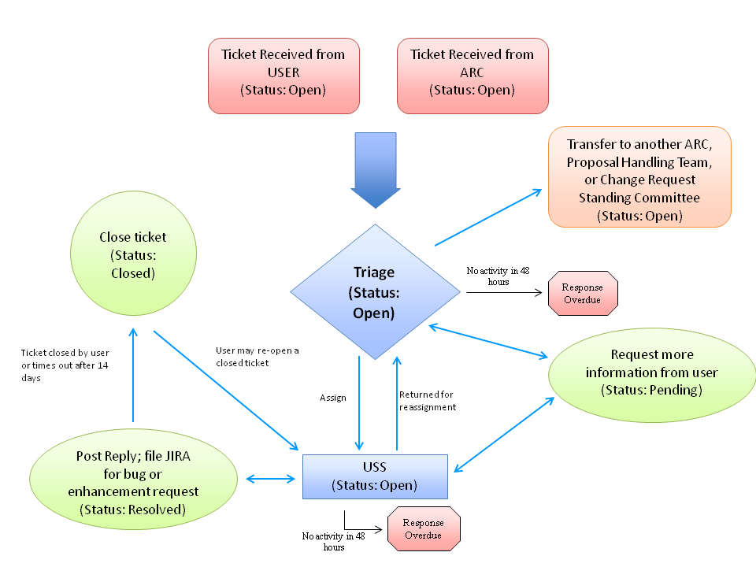
Figure 1: Helpdesk workflow

Resolved
A reply to the ticket has been posted by a USS, which they believe solves the problem. Also, if the user has submitted either a bug report or enhancement request to a software subsystem, e.g. a new feature in SIMDATA or new Virtual Astronomical Observatory (VAO) access to Splatalogue, that ticket should also be posted as “Resolved” and the appropriate ticket should be filed to the corresponding bug-reporting system (Appendix D). The reply will include a request to the user to close the ticket if they are satisfied with the response. If no action is taken by the user, the ticket is “Closed” after 14 days. The user will then be informed that their ticket has been closed.
NOTE: Following standard commercial helpdesk practice, a USS does not close tickets. This is left to the user. The resolved status is necessary so that tickets are not constantly closed and re-opened by users or a USS in the process of answering the ticket. As such, the ticket remains in the “Resolved” status until the user is satisfied with the response.
It is also possible that a user can reply to a “Closed” ticket. This action will automatically re-open the ticket and dialog in the helpdesk. It is appropriate if the user is not happy with the resolution but in this case, triage should see the reply to this ticket which has been automatically re-opened and then request from the user that they open a new ticket if this is a new issue or clarify the response to the ticket if the initial reply did not adequately resolve their issue (Figure 1).

Response Overdue
If there has been no action taken on a ticket by either triage or a USS within the 2 working day time window described in Section 2.3.1, the status of the ticket will change automatically to “Response Overdue”. (See Figure 1).
Also, if a USS replies to a ticket but does NOT set the status to “Resolved” the ticket will remain “Open” indefinitely unless the user changes the status of the ticket to closed. Because of this, it is important for the USS to set the ticket status to “Resolved” after posting a reply (Section 2.3.3).

Closed
A ticket will be set to the “Closed” status if:
- The user has reviewed the response to the resolved ticket, has agreed the answer is satisfactory and closed the ticket.
- The ticket is closed implicitly through the user not responding within 14 days of the ticket entering the “Resolved” status.
- The ticket subject is inappropriate for resolution by ARC staff (such tickets may be closed directly by Triage or another USS).
Note that “Closed” tickets do not show up in the default ticket views (Figure 5); to view them, change the view to “all tickets” or create a new view (Section 7.4.1). A ticket in the “Closed” status will never default to a status of “Response Overdue”.

ALMA Helpdesk Departments

The ALMA helpdesk has the following departments set up viewable by a user to send tickets to the user’s affiliated ARC:
- General Queries (Science Portal/Registration, Documentation, Webpages, Proposal reviews and assessment, Project tracking, other)
- Project Planning (Available Capabilities, Call for Proposals, Sensitivity Calculator, Simulators, Splatalogue, other)
- Observing Tool (Proposal Preparation, Proposal Submission (general), Phase 2 process)
- Data Reduction (Common Astronomy Software Applications [CASA], pipeline processing)
- Archive and Data Retrieval (archive access and queries, obtaining your ALMA data)
- Face to Face Support (Data reduction, sabbatical, science, short term, other)

In addition, the ARCs have also set up internal departments in order to request assistance from the PHT and CRSC. These departments are not seen by the users and are only used by ARC staff.
During Cycle 1, each ARC has set up a Cycle 1 Observing Programs Department where ARC staff can directly correspond to PI’s of accepted projects during the process of scheduling block verification and submission through data collection and processing. Tickets are open by ARC staff on behalf of the PI and the correspondence the ARC staff has with the PI on that particular project is contained in that department. Each ARC has set their own workflow regarding how ARC staff communicate with their PIs and in setting the overall status of tickets. See your local helpdesk manager for the appropriate workflow for this department.
All three ARCs share a single database, so departments can be set up such that all tickets get sent to a single ARC or to all three ARCs. The single database also allows transfer of tickets between ARCs whilst retaining the ticket ID and work logged on that ticket. A software bug-reporting system has been set up so that ARC personnel can submit tickets to the Department of Science Operations (DSO) in cases where a user ticket finds a bug or requests an enhancement to one of the ALMA software tools, systems or subsystems (Appendix D). The Knowledgebase is also common to all three ARCs and will be described in more detail in Section 4.

Proposal Submission Emergency Department
During the last week before the Call for Proposals, a single department called “Proposal Submission Emergency” is set up across ARCs that will answer urgent tickets concerning proposal submission. Triage for this department will start 36 hours before the deadline with 24-hour coverage by Europe (EU), North America (NA) and East Asia (EA). EA will open and EU will close the dept at 15UT according to the following schedule:

- EA: 03 - 09 UT (12PM - 6PM Local Time)
- EU: 09 - 15 UT (11AM - 5PM Local Time)
- NA: 15 - 00 UT (11AM - 8PM Local Time)
- EA: 00 - 08 UT (9AM - 5PM Local Time)
- EU: 08 - 15 UT (10AM - 5PM Local Time) - 15UT - Proposal Deadline

A handoff from one ARC to another will take place when the appropriate time is reached. In addition, a representative from the Joint ALMA Observatory (JAO) will also be “on call” 24 hours per day starting 36 hours before the proposal submission deadline to help resolve urgent problems with proposal submission. Contact information will be available (phone numbers and email addresses) at:

http://wikis.alma.cl/bin/view/DSO/JAO_On_Call_wiki

After the JAO has resolved the problem they will report back to the Triage who reported the problem and the solution. Finally, Triage will contact the users directly by posting replies to the submitted tickets.

Knowledgebase Articles
Solutions to one user’s tickets cannot be seen by other users. If a solution is potentially useful to other users, the solution should be published as a Knowledgebase (KB) article. KB articles can be searched by anyone at any time and do not require login to the helpdesk. The goal is that most queries will be answered if the KB articles are written appropriately.

In the process of typing their question in a helpdesk ticket, the user is also dynamically searching KB articles. Relevant KB articles will begin to appear in the page as a user types. As such, the subject line of the article should be indicative of the solution or in the form of a question and text of a KB article should be descriptive, including as many key words as possible that may be relevant to the article solution and include as many title words as possible because the automatic KB search only scans the text of the KB articles and not the titles. The KB article also must be published in English and there should be no identifying information that a user may consider proprietary. Therefore, answers to tickets specific to individual sources may have to be made more general to be published as a KB article.

KB articles should endeavor to reference existing documentation, even for general radio astronomy questions. However, KB articles should not answer questions on IT or computer hardware issues. KB articles on general Mac, PC or Linux related issues should not be included in the KB. Rather, articles should be ALMA or ALMA-software specific. Finally, KB articles should avoid using terms like, “now”, “at this time”, or “currently.” Instead the articles should refer to the current or upcoming observing cycle (e.g. “during cycle 0 observations…).

KB articles can have a status of “Draft”, “Pending Approval”, or “Published”. A draft article is NOT visible for general public viewing. These articles are visible to other USS, Triage, the helpdesk manager and administrator. When a USS is ready for a KB article to be made public, they click “Publish” and the article status changes to “Pending Approval”. Triage staff will review the article for clarity, scope and content ensuring that no proprietary or personal information is conveyed in the article. If there is any question about the proprietary nature of the information contained in the article, the USS should contact the initial user who submitted the ticket and confirm the requisite information may be posted for public viewing. Once the triage staff member agrees the article is ready for public viewing, the article status can be changed to published. At this point the article will appear in the general KB article search off the main helpdesk page. Each ARC has the responsibility for appointing one or more members of the triage staff to moderate KB articles written by USS.

Finally, the helpdesk is set up to make all Knowledgebase articles public and visible to all ARCs. This should not be changed except in exceptional circumstances. Should it be required, however, to have a knowledgebase category only visible to a single ARC (perhaps for language reasons), it is possible to make new categories (Knowledgebase -----> Insert Category) and to adjust the visibility of this to the other ARCs by hitting “Permissions: Users”.

Reports and Ticket Tracking
In accordance with the Helpdesk System Requirements (Req-11), the helpdesk must have the ability to generate reports. To minimize customization of the Kayako software, reports are generated by an outside web application; screenshots of the application are shown in Appendix C. Staff members can access the reports at the following URL using their Helpdesk Staff login credentials.

https://help.almascience.org/reports

Several reports are accessible at this URL, depending upon the privilege level of the staff user. The following is a description of the reports available at each privilege level:

Level-1: User Support Specialist

- Ticket Tracker - allows a staff member from any ARC to view the status of a ticket that has been transferred to another ARC. Simply enter the ticket ID, and a summary of its contents, including the audit log, will be displayed.
- Knowledgebase Articles - Summary of KB articles, including status, author and editors.
- Department Summary - Department statistics across ARCs.
- Summary over Time - Statistics for a given time period.

Level-2: Triage Staff

- Includes all the Level-1 reports and also the following 2 searches.
- Ticket Search - allows the triage staffer to search for tickets by a variety of filtering criteria. (e.g., owner staff name, ticket status, ticket submission date range, department, select public departments only)
- Ticket Assignment Statistics - provides a detailed report on the number of tickets assigned to staff members during a specified time period.

Level-3: Helpdesk Manager

- Includes all the Level-1 and -2 reports, with the added capability of viewing combined statistics across both the NRAO and ALMA helpdesks.

Ticket Servicing Rules
The ALMA helpdesk will need to have a uniform service level between the ARCs (so far as practical). Replies shall be courteous and professional in tone. In addition, direct emails between the USS and the user (outside the helpdesk) should be avoided so far as possible.
- Users will receive a customized reply to their ticket within 2 working days of receipt by the ARC. Ideally, this would be a resolution of the ticket, but could simply be a statement that the ticket is being worked on and, if possible, with an anticipated timescale for resolution. Ticket replies will be sent through the helpdesk rather than in the form of a personal email.
- If a helpdesk ticket is assigned to a USS by triage, the USS should make sure that “due diligence” is done in order to find the correct resolution to the ticket. In many cases this may mean that a USS may need to review and revise the existing documentation or consult with other experts to resolve the ticket.
- When a ticket is passed to another ARC (section 9.1), the triage at the initial ARC will send a reply to the user through Kayako stating that the ticket has been transferred. When the ticket is received by the recipient ARC, it is treated as a new ticket, with a customized reply being sent within two working days. Responsibility for that ticket is considered transferred to the receiving ARC.
- Open tickets that require clarification or technical details from the user will be set to “Pending” until the appropriate information is received. At the same time, a reply will be posted to the user stating the ticket status and giving a reason why the ticket has not been resolved.
- When a helpdesk ticket reports a problem or requests and enhancement to an existing ALMA software tool, system or subsystem:
  - Triage first checks the “known issues” page to see if the bug or enhancement request has already been posted before assigning the ticket to a USS for verification.
  - For a software bug report, the USS assigned the ticket should provide due diligence to
    - verify that the problem is not a user error, a result of improper documentation, or something other than a true software bug, and, subsequently,
    - attempt to replicate the problem using a system (operating system, software version, etc.) as close as possible to that used by the submitter, provided it is within supported specification for the software in question.
  - If a ticket is verified to be a request for an enhancement or reports a bug to one of the existing ALMA software tools, systems or subsystems, the ticket is assigned to the cognizant lead or certified representative (see Appendix D); the cognizant lead should submit a ticket (or similar) to the appropriate agency (typically JAO/DSO or ICTIPT), and “Resolve” the helpdesk ticket stating that a ticket has been filed and providing a link to the appropriate ‘known issues’ page. There will be a 'known issues' page for each software subsystem that can track bug and enhancement requests (CASA and the ALMA-OT already have said pages) managed by the subsystem scientist. The known issues pages will ensure that the Knowledgebase articles need not be updated for every change in the enhancement request or bug fix status.
  - The ticket is then set to “Resolved” because the issue is already being tracked in the bug reporting system and the user’s helpdesk request should be accommodated. This workflow eliminates the need for ticket to go to “On Hold”. Users can then track the progress of the ticket off the “known issues” page or re-open the ticket if they don’t see their issue reported.
  - Ticket resolutions that are likely to be of interest to other users and are not already in the Knowledgebase should be added to the Knowledgebase (as a “Draft”) by the USS when they resolve the ticket. Information that could identify the ticket submitter or could be considered proprietary (such as target coordinates) should be removed from the article prior to publication in the KB (Section 4). This draft article will then be submitted for publication after it has been given the appropriate review.

- A USS will sometimes need to submit a ticket on behalf of a user. This may happen under a number of possible conditions including:
- a ticket concerns more than one system (e.g. a question on the Observing Tool [OT] and Simulator in one ticket) and the USS wishes to segregate the systems and deal with each in a separate ticket;
- a user is having problems logging into the helpdesk via the Science Portal.
- The results of the Phase 2 scheduling block generation need to be reported to the PI of an accepted ALMA cycle program and the contact scientist has been identified.
Under these conditions the USS should click the “Tickets” tab, select “New Ticket”, “Send Mail” and then choose the correct department in which to open the new ticket. When opening a new ticket on behalf of a user, it is important to use Kayako’s autocompletion feature when entering the users email address in the “To” field. Autocompletion performs a real-time match of email addresses in the ALMA Science Portal with the text entered in the “To” field. It is not advisable to open a ticket for a user not yet registered with the Science Portal; instead, have the user register with the Portal and then create a ticket for them using autocompletion.

Staff interface details
In this section we will highlight parts of the helpdesk most likely to be used by ALMA staff.

Staff view: logging in
To login and access tickets as a staff member, staff should visit the following site:
https://help.almascience.org/staff

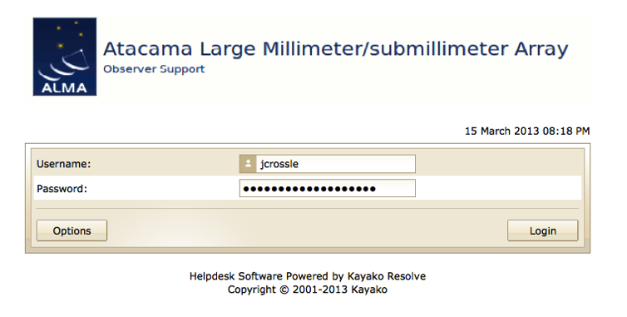
Figure 2. The staff login view.
and login with their staff account provided to them by their local helpdesk administrator (Section 2.1). The login window for staff is shown in Figure 2. Upon login, staff will be directed to the helpdesk staff dashboard appropriate for their parent ARC. This will show the departments of which the staff is a member, and notifications of new, updated and overdue tickets (see Figure 3).

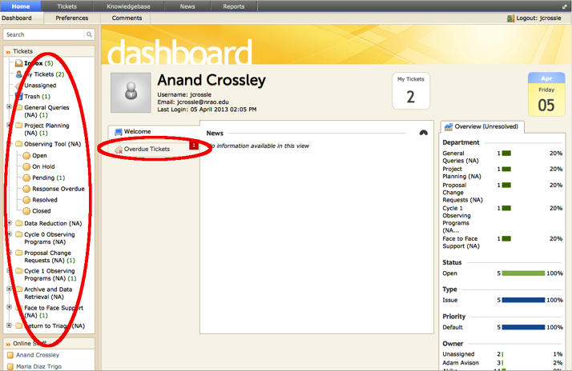
Figure 3. Default dashboard view under the “Home” tab showing all departments associated with that ARC and recent helpdesk activity.

“Home” Tab
The dashboard, described above, is accessed through the “Home” tab and is shown in Figure 3. From this tab, staff may use the “Preferences” menu to control settings and change their password. For example, to change your staff account email, follow: Home ---> Preferences ----> <change email address> -----> Update (Figure 4).
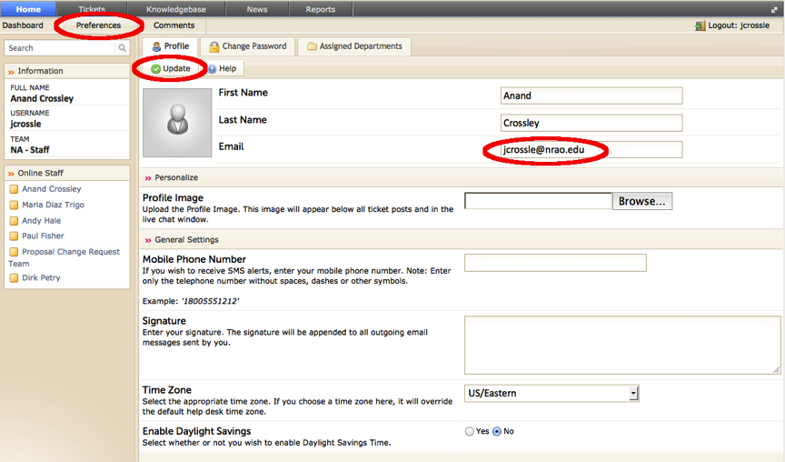
Figure 4: Changing your notification email address

Notifications
A notification is automatically sent by the helpdesk as an email (or Short Message Service - SMS) so a staff member is notified of helpdesk activity that may concern them, such as when a ticket is assigned to them. By default, a staff account is set up by the helpdesk administrator to receive email alerts according to their helpdesk role.
The default notifications for the following roles should be:
USS:
- New Client Reply
- New Note
- Status Change
- Ticket Assigned
Triage:
- New Ticket
- New Client Reply
- Ticket Move – will get notification if the ticket is transferred, moved or returned to triage
- New Note
- Status change – will get notification if the response is overdue
- Ticket Assigned
Manager:
- Same as triage but add Ticket Closed.

For the USS, notifications should only be set to run for those tickets assigned to the USS, for all departments, all ticket statuses and all ticket priorities. Note that when you make changes to a ticket, notifications will not be sent to you. Notifications are only sent to you for ticket changes made by other staff or users.
For Triage, the notification options for Ticket Assigned, New Client Reply and New Note should be set only to run for those tickets already assigned to Triage, for all departments, all ticket statuses and all ticket priorities. However, for New Tickets, Ticket Move and Status Change, the Triage should received notifications for all tickets, not just those assigned them. The helpdesk manager should track all tickets.
The Kayako helpdesk notifications are highly customizable and may be modified by any triage staff person. If you wish to change your notification settings please consult with the triage staff or helpdesk manager at your ARC for guidance.

“Tickets” Tab
Under the “Tickets” tab are options for viewing tickets, searching for tickets, and filtering tickets.

Viewing Tickets
To view tickets: Tickets ----> Manage Tickets.
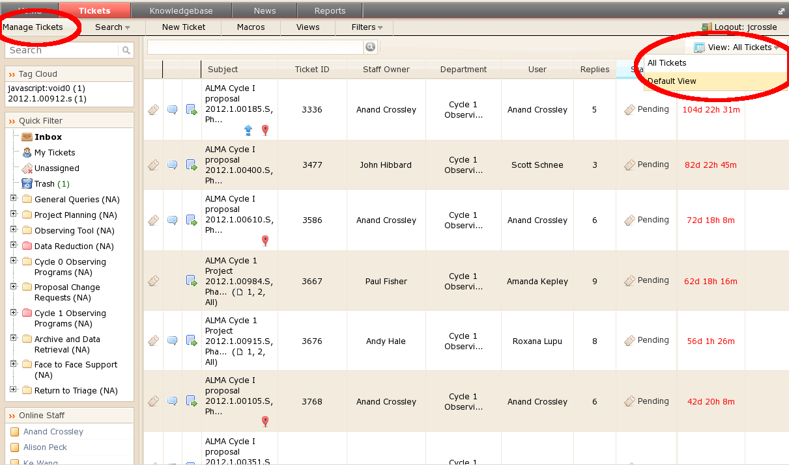
The way the helpdesk displays tickets is controlled by the active “view”. A view defines criteria for displaying tickets in the main ticket table (e.g. only display tickets that are owned by the active staff person) and the columns displayed in the table. After clicking “Manage Tickets” the active view can be changed by clicking on the pull-down button just above and to the right of the displayed ticket table (Figure 5). By default, there are a limited number of public views that have been set up for USS. The “Default View” shows all tickets that have not been “Closed” and are assigned to the staff member; the “All Tickets” view shows all tickets that have not been “Closed”. As a rule, “public” views should not be edited except by the helpdesk administrator.
Figure 5: Selecting a view – USS can create new private views but should avoid editing the public views.
A USS has the ability to set up any number of “private” views. To create a new private view: Tickets -> Views -> New. (Figure 6)
Once a list of tickets is shown in the main ticket table, clicking on either the ticket ID or the subject will allow the ticket text to be viewed.

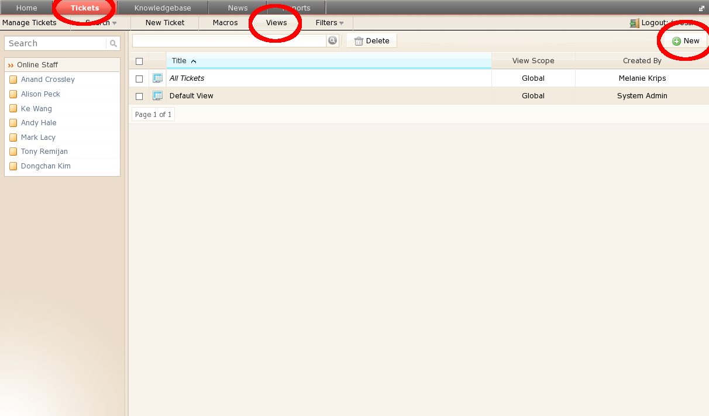
Ticket Filters
Figure 6: Create a new private view by clicking "Tickets", "Views", and "New".
The Kayako helpdesk includes the ability to filter tickets displayed in the active view and to search for tickets. There are 3 ways to filter tickets.
First, on the left-hand side of the Kayako interface web page is an area headed “Quick Filter”. Clicking a quick filter will filter the displayed tickets in several different ways, including displaying all tickets assigned to the active staff or displaying only tickets for a particular department (see left circle in Figure 7).

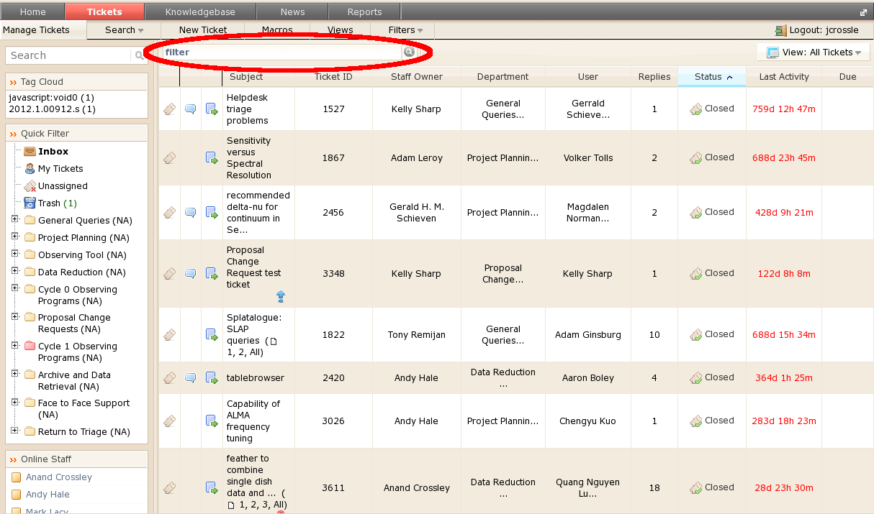

Figure 7: Filter the tickets by using the “quick filter” or the “filter box” above the main ticket table.
Second, when viewing tickets, there is a text box above the main ticket table. Enter text in this field and press return to filter all currently displayed tickets. Note that this filter will persist when changing departments using the quick filter side bar. To remove the filter, simply delete your text from the text box and press return again.
Third, under the tickets tab, the “Filters” pull down menu reveals additional customized filters and the ability to manage filters. To create a new filter click Tickets -> Filters -> Manage -> New (Figure 8). Tickets can be filtered on many properties such as subject, status, owner, time since creation, last activity, et cetera. Note that a “private” filter will only be visible to the staff person who creates it; “public” filters will be visible to all staff.
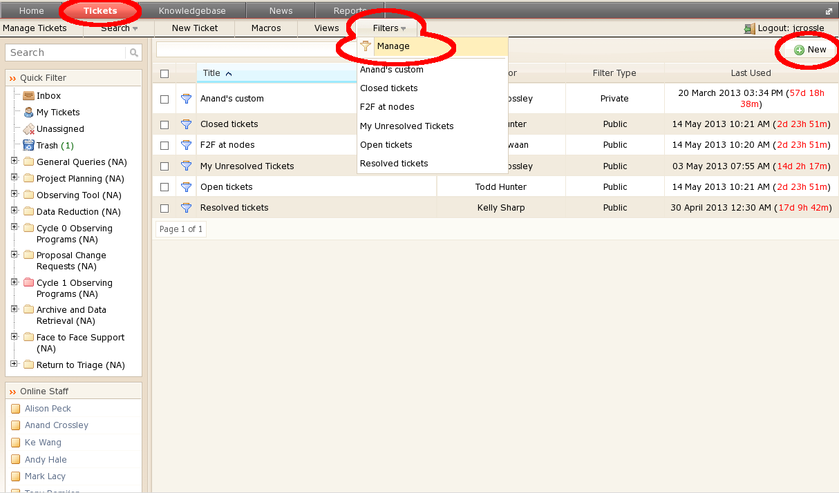
Figure 8: To create a new filter, click “Tickets” -> “Filters” -> “Manage” -> “New”.

Ticket Search
There are two ways to search for tickets in the helpdesk. The first is using the “Search” text box at the top of the left side bar. Text entered here will generate a drop down list of matching tickets, knowledgebase articles, user accounts, and user organizations. This drop down list is not exhaustive, but rather contains the results most likely to be of interest.
The second search mechanism is the pull down menu on the Tickets menu bar. Click: “Tickets” -> “Search”. From this menu you can search for tickets in various ways including: listing all new tickets, searching for tickets by “Creator” or “Replier” name, searching for tickets by ticket ID number, performing a “Quick Search” over all ticket metadata, or performing an “Advanced Search” over specific ticket metadata.
Occasionally searches and filters do not return the correct results. For example, you may find zero matches to a search where you know there should be some. If this happens, a workaround is to first change to a different view (Section 7.4.1), and then change back to your original view. After doing this repeat your search or filter.
When performing a search or filter using the pull-down menus, a “Results are Filtered” button with a red “X” will display at the top left of the main ticket table. This button is a reminder that the table you are currently seeing is a filtered list of the total number of tickets available through your current view. To remove the filter, click the red “X”.

User Support Specialist (USS)
By default, the USS will receive email notification of a ticket being assigned to them. NOTE: If you do NOT get an email notification, your notifications may not have been set up properly or may have returned to their default values. In this case, refer to Section 7.3 on what notifications should be set up for a USS.

Standard Helpdesk Tasks
- Examining a Ticket
The USS will login to the helpdesk (Section 7.1) and view tickets using the “Manage Tickets” tab (Section 7.4.1) or using one of the quick filters on the left side-bar (section 7.4.2). Once the USS has located the ticket they wish to work on, clicking on the ticket ID or Subject will open the ticket (Figure 9).

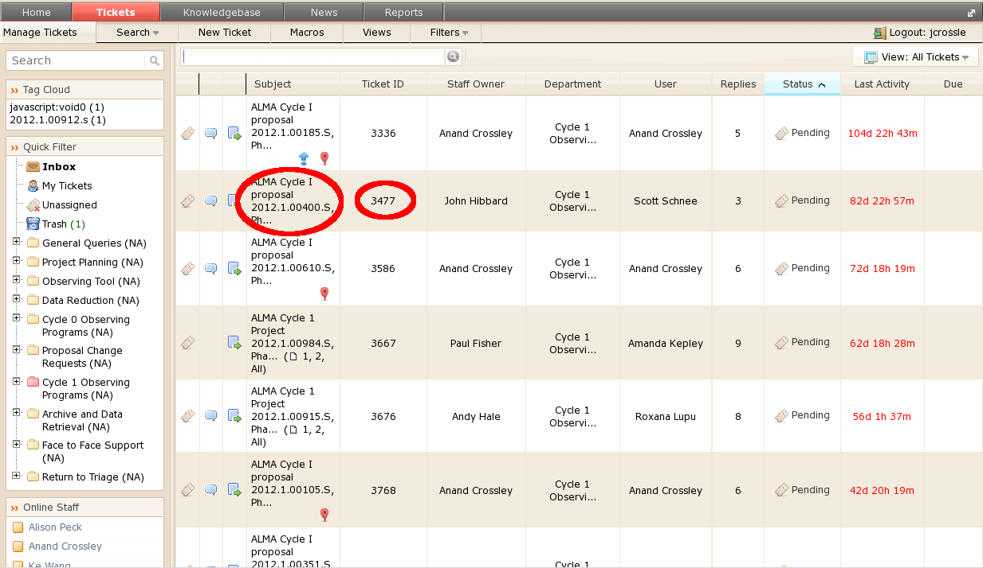
Figure 9. Selecting a Ticket. Click on either the ticket ID or Subject to open a ticket.
- Posting a Reply to a Ticket
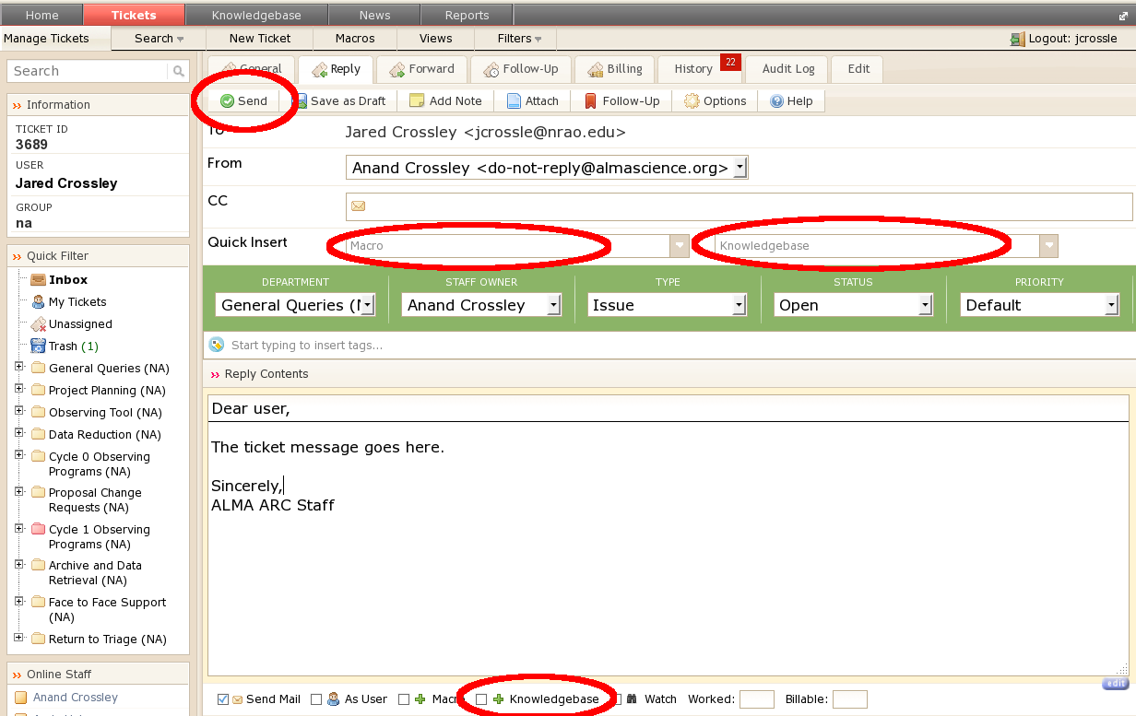
If the USS believes they can answer the ticket or require more input from the user, the “Reply” tab allows a reply to be made to the ticket. In addition to the large text box where a reply can be written, there are also options to place pre-defined replies or knowledgebase articles into the reply by clicking on the “Macro” or “Knowledgebase” pull-down menus above the reply box (Figure 10). Hit “Send” to send the reply to the user. To capture the resolution of the ticket into the knowledgebase, check the “+Knowledgebase” box to the lower right before hitting “Send”. The user will receive an email that contains both a link to the ticket as well as the resolution submitted in the text of the email.
After replying to a ticket, the USS should check to be sure the ticket status is set appropriately (section 8.1.3).
Figure 10: The “Post Reply” tab view. A USS can either select from a predefined set of replies called “macros” or knowledgebase articles. In addition, it is possible to capture the reply to the KB by selecting the “+Knowledgebase” checkbox.
It is possible by changing the views, that a USS can see tickets that they have not been assigned. It is left to each ARC to decide whether or not a USS can reply to a ticket that has not been assigned them. Under all circumstances, a USS should feel free to add notes to a ticket that can be either viewed by everyone or a particular USS (Section 8.1.4).
- Changing the Status of a Ticket

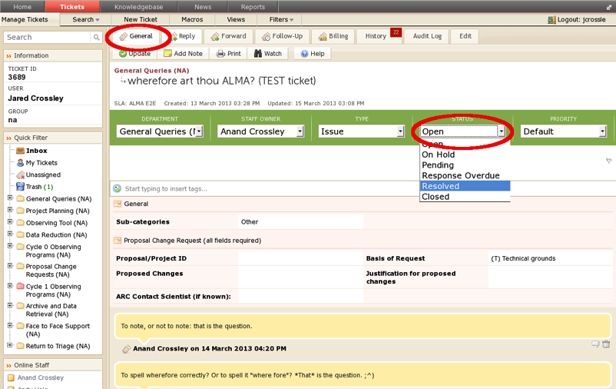
The USS should change the status of a ticket as necessary after posting a reply. The status should be based on the action required/needed for that ticket (Section 2.3). To change the status without posting a new reply, select the “General” tab, click on the status of the ticket, and use the pull-down menu to select the new status (Figure 11). To change the status of the ticket while posting a reply, select the “Reply” tab, click the status of the ticket, use the pull-down menu to select the new status, enter the reply text and click “Send” (Figure 12). REMEMBER, a USS should not close a ticket (Section 2.3.5).
Figure 11: Changing the status of a ticket inside the “General” tab.
- Adding Notes to a Ticket
Tickets may be annotated by a USS without these notes being visible to the user. Notes can be applied on a per-ticket basis (for example, to request Triage transfer to another ARC), or on a User basis (for example, to inform other USS about issues with a particular user, e.g. a poor internet connection). The USS can also control whether the note is visible to all USS, or only a specific USS (for example, the helpdesk manager). To add a note to a ticket, select the ticket and click the “Add Notes” tab above the ticket header (Figure 13).
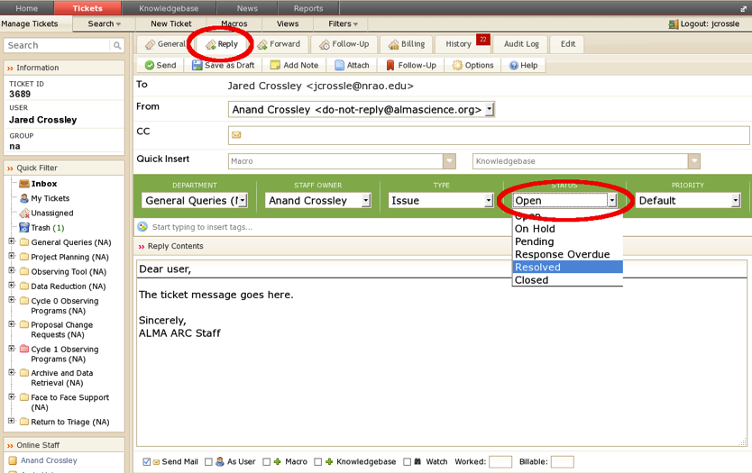
Figure 12: Changing the status of a ticket inside the “Reply” tab.
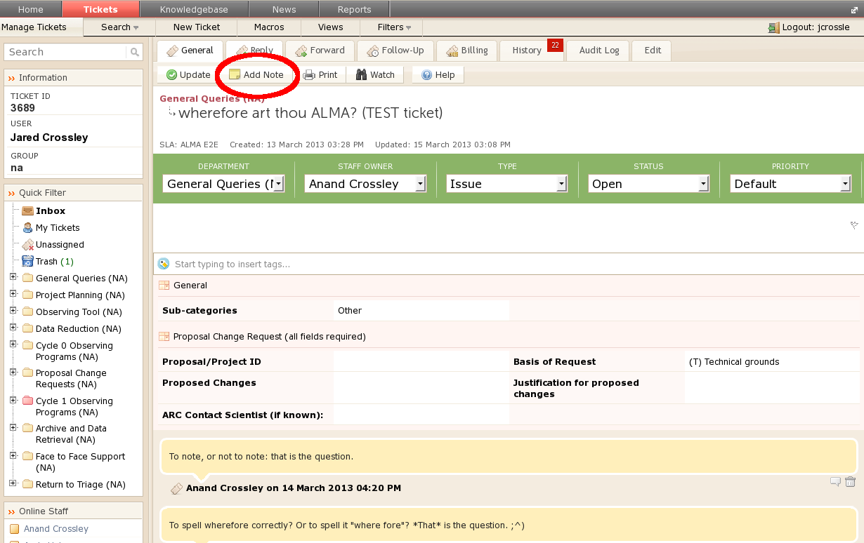

Figure 13: Adding a note to a ticket inside the “Add Notes” tab.

Adding a Knowledgebase Article
If the resolution of a ticket is likely to be of general interest to the ALMA community, a knowledgebase article should be filed (Section 4). To do this, check the “+Knowledgebase” box below the reply box (Section 8.1.2) before sending the reply to the user. This will take the USS to the Knowledgebase article editor directly, with the body of the ticket reply included. The article should be edited to remove any information that would identify the user, and should not include any information that the user might consider proprietary (e.g. specific astronomical sources). The subject and category of the article should also be entered before the article is inserted and before submission. See Section 4 for guidelines on creating knowledgebase article subject lines.
The USS should save temporary changes using the “Save as Draft” button (Figure 14). When the article is ready for publication, click “Publish”. Designated representatives from each ARC will then review the draft KB articles before they are published.
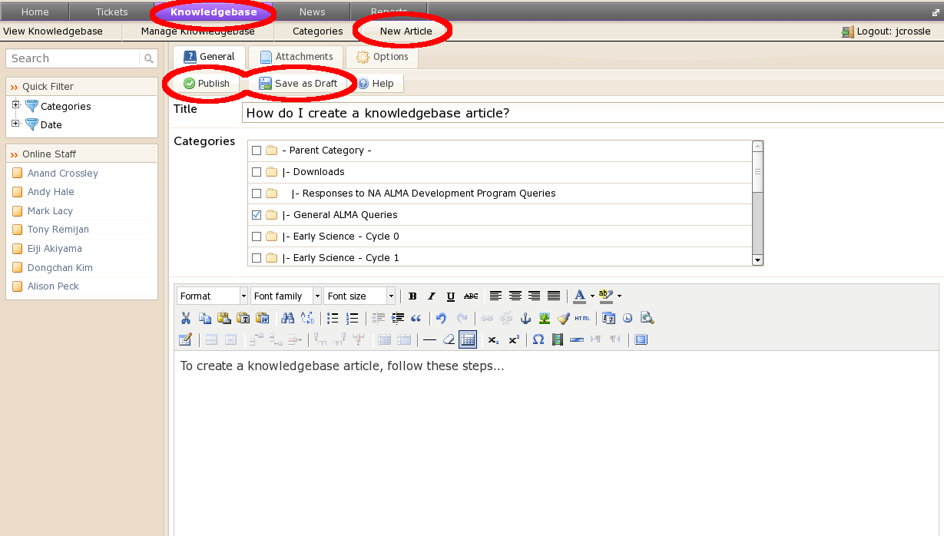
A knowledgebase article may also be added independently of the ticket reply by hitting the “Knowledgebase” tab on the top row of tabs, then “New Article” on the second row. For more specifics on displaying the content of Knowledgebase articles, refer to Section 4 and Appendix C.
Figure 14: To create a new Knowledgebase article click “Knowledgebase”, “New Article”, enter the title, assign the proper categories, and write the text of the article. Finally, click “Save as Draft” to save and edit later, or click “Publish” to mark the article as ready for publication.

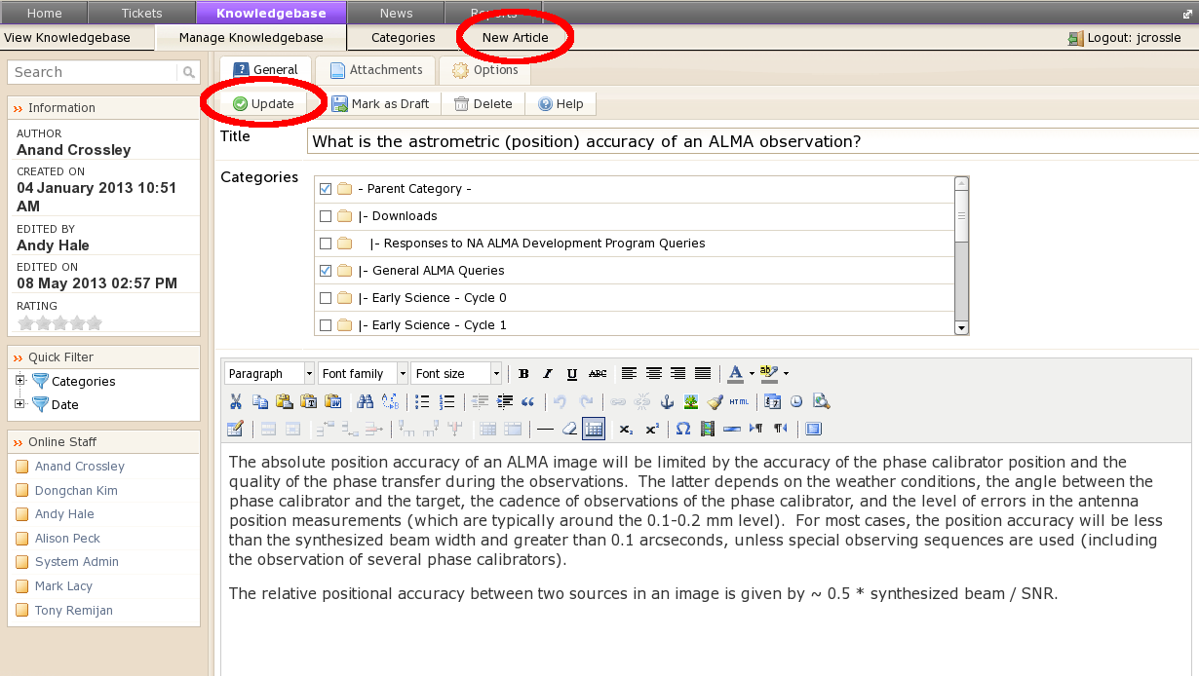
Figure 15: Adding a Knowledgebase article. The above view will be the same if you enter through the “Post Reply” tab and select the “+Knowledgebase” option.

USS Procedure for Responding to Tickets
- Determine whether they are capable of resolving the ticket without further help from another ARC, or further input from the user. Respond to the user (Section 8.1.2) and change the ticket status to “resolved”. They should file a knowledgebase article if appropriate (Section 8.2).
- If the ticket requires further information from the user (for example, operating system details), a response should be sent to the user requesting this, and the ticket status set to “Pending” while awaiting a reply (Section 8.1.3).
- If the USS believes the ticket needs to be sent to another ARC (Section 9), they should change the department to “Return to Triage” (Section 2.2.2) and add a note to the ticket (Section 8.1.4) describing which ARC it should be sent to and why.
- If the USS is unable to respond to the ticket (for example, because they lack the specialized knowledge to do so, or because they are unavailable) the ticket should be returned to Triage (Section 2.2.2) with a note explaining why it was not answered, and recommending assignment to another USS. This should only happen in exceptional circumstances. In general, a USS should always attempt to answer the ticket themselves, if necessary by asking appropriate experts (Section 6).
- If the USS is the cognizant lead or has been certified by the cognizant lead for a particular software subsystem, they should follow the workflow described in Section 6 and change the ticket status to “Resolved” when an enhancement request or bug fix is submitted to their particular software subsystem. If not a certified USS, they should return the ticket to Triage once the bug has been confirmed and request reassignment to the cognizant lead.

Ethics in USS Support
Given the nature of support provided by the helpdesk system, it is possible that an extensive amount of correspondence between the USS and user may be required to resolve a particular helpdesk issue. It is not ethical for a USS to ask to take part in a project in exchange for the additional help offered through the helpdesk. In other words, USS should not try to become collaborators on projects using the helpdesk.
If the ALMA user asks the USS to take part in the project given the expertise they have provided, the USS may join the project. The request from the ALMA user that the USS join the project must be captured in the helpdesk.
If there is any question as to the ethical nature of the user’s request for a USS to join the project, the USS should discuss the issue with either the Helpdesk or ARC manager before making a decision.

Management
The Helpdesk manager at each ARC is responsible for ensuring that the agreed to service expectations are met, and for scheduling triage personnel to ensure service coverage. He/she is also responsible for providing reports to the ARC management on Helpdesk usage and statistics on the response times and distribution of tickets by status (“Open”, “Pending”, “Resolved”, “Closed”).

Getting Input From Other Parts of the Project
There are times when staff outside of a given workflow will need to see a ticket. These staff include, but aren’t limited to, specialists at the other ARCs, or staff of the JAO. With this in mind, it’s important to remember that only members of the ARCs should interact with their users directly.

Transfer of Tickets Between ARCs
As discussed in Section 2.2.1, Triage has the ability to transfer tickets between ARCs. This mechanism is intended to allow the helpdesk to leverage the worldwide expertise available to ALMA. However, this process should not be done lightly and the mechanism should be used only in the following circumstance:
- A ticket is submitted and assigned to a USS at one ARC. The USS knows specific expertise exists in another ARC. In general, we prefer that the USS contact the person with expertise at the other ARC directly (on the basis that exchanging knowledge is preferable to exchanging tickets). The solution sent by this other USS should then be contained in the ticket response and in these cases especially, a Knowledgebase article should be published. Failing this, however (for example, if the query is unusually complicated), the ticket can be returned to Triage with a note (Section 8.1.4) from the USS in the originating ARC explaining the reassignment.
When a request for a ticket to be transferred is sent by a USS back to triage:
- The USS must include a note (Section 8.1.4) in the ticket that explains why he is requesting reassignment rather than contacting the relevant expert directly.
- Triage should send a reply to the user explaining that his ticket has been transferred to another ARC.
- Upon receipt by the receiving ARC, the ticket should be treated as a new ticket and assigned to the appropriate USS.

Transfer of Tickets to the Proposal Handling Team
There are specific times when the PHT will be needed to assist in resolving a helpdesk ticket. The cases that apply to PHT support are: OT emergency submission, proposal handling, and also some cases for proposal assessment (those concerning details of panel or email notifications to Principal Investigators [PIs]). For those tickets that require assistance from the PHT, Triage will follow the workflow listed below:
- Triage will assign the ticket to himself or herself.
  - If triage has already assigned a ticket to a USS and after correspondence with the user, the USS determines the ticket needs to be sent to the PHT, the USS transfers the ticket back to Triage but retains ownership of that ticket.
- He or she then transfers the ticket to one of 3 separate private departments of the helpdesk (Proposal Handling – NA, EA, EU), it is then put in to the “Pending” state.
- When a ticket is assigned to this department, the PHT account alerts have been set up so that the PHT will get an email alert that a new ticket has been submitted. A PHT account for the helpdesk will include an email exploder to the entire PHT.
- However, in order for that ARC not to lose control of the ticket, triage does NOT assign the ticket to the PHT.
- The PHT will add a note(s) to the ticket with the resolution.
- The ARC triage staff or USS then replies to the user.
As with all tickets, staff should use predefined macros (see section 8.1.2) when appropriate. This workflow ensures that only members from the ARCs interact with their users.

Transfer of Tickets to the Change Request Standing Committee
For those tickets that require assistance from the CRSC, Triage will follow the workflow listed below:
- Triage will assign the ticket to himself or herself or to the contact scientist assigned to user’s project (if one is assigned).
- Refer to [RD4] to determine if the change request is minor or major. Minor change requests (e.g. small updates to a source position or velocity, etc.) should be discussed with and approved by the Contact Scientist; these do not require involvement of the CRSC.
- Major changes (e.g. changing targets, mapping area, spectral windows, or any changes that increase the estimated execution time) are to be discouraged by the Triage staff; though the option of still referring the request to the CRSC should be made.
- At no time during this process should the CRSC be explicitly mentioned. Correspondence should only refer to the “ALMA Directors.”
- It should be pointed out in the message to the requester that the proposal change request may be denied and during review of the request, all observations for their project will be suspended until a decision is made by the CRSC (in the guise of “the ALMA Directors”). A predefined macro (see section 8.1.2) is available for this purpose.
- If the requester would still like this referred to the CRSC, Triage then transfers the ticket to one of 3 separate private departments of the helpdesk (Proposal Change Requests – NA, EA, EU) after making sure all the required fields have been properly filled out.
- When a ticket is assigned to this department, the CRSC account alerts have been set up so that the CRSC will get an email alert that a new ticket has been submitted. A CRSC account for the helpdesk will include an email exploder to the entire CRSC.
- However, in order for that ARC not to lose control of the ticket, triage does NOT assign the ticket to the CRSC.
- The CRSC will add a note(s) to the ticket with the resolution.
- The ARC triage staff person or the contact scientist for the project then replies to the user again using the predefined macro for this purpose.

This workflow ensures that only members from the ARCs interact with their users.

Procedures for Responding to tickets – Triage
By default, as described in setting up the notifications in section 7.3, Triage personnel at the ARC will receive email notification that:
- a new ticket has been received
- a new client reply has been received
- a ticket has been transferred from another ARC
- a ticket has been returned to triage
- a new note has been posted
- a ticket’s status has changed to overdue
- a ticket has been assigned to the triage staff person

NOTE: If in your role as Triage, you do NOT get an email notification; your notifications may not have been set up properly or may have returned to their default values. In this case, refer to section 7.3 on what notifications should be set up for a triage staff member.
The on-duty triage USS will then login to the helpdesk (Section 7.1) view tickets to find the ticket in question (Section 7.4.1).

In addition, it is also possible that triage may receive a reply from a user that is not directed to the response posted by the USS assigned to their ticket, (e.g. asking a new question). In this case, triage should post the contents from the user in a note attached to the ticket and in the future try to discourage this correspondence, for example, by suggesting that they open a new ticket. The formal workflow for these types of tickets though is managed by the individual ARCs (see ARC specific staff guide).

Examining a Ticket

Assigning a Ticket
If Triage believes this ticket requires USS expertise, they will assign the ticket to the appropriate USS. The “General” tab allows (re)assignment of a ticket through clicking on “-Unassigned-” in the “Staff Owner” field in the ticket header (Figures 16 and 17).

Figure 17: View after -Unassigned- has been selected. Triage can now select an owner for that ticket.
Figure 16: The “General” tab after a ticket has been opened. Click on -Unassigned- to (re)assign that ticket to a USS
NOTE: While it is possible for a USS to reassign a ticket to another USS, this is not the recommended workflow (Section 2.2.2) and should be avoided.

Changing the Department of a Ticket
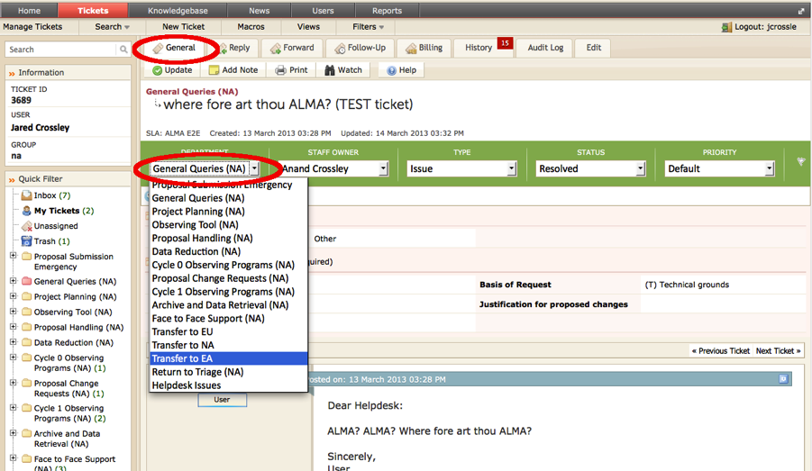
Occasionally a USS will need to change the department of a ticket. For example, an EU or EA user may submit a ticket to visit the NA ARC. In this case, the workflow should be that a user who wants to visit a non-regional ARC submits a ticket to their region to the Face-to-Face Support department and then triage will change the department of that ticket to the appropriate ARC’s triage. Clicking on the “General” tab allows the department of a ticket to be changed through clicking on the Department field in the ticket header (Figure 18).
Figure 18: Changing the Department of a ticket inside the “General” tab.

Forwarding Tickets
Sometimes it is useful to be able to forward a ticket via email out of the Kayako system, for example, to solicit the help of an expert who does not have a Kayako account. To do this:
- click on the ticket subject and hit “Forward”
- Enter the email address of the intended recipient.
- The USS will probably also want to change their email address from the “do-not-reply” default to their actual address, which can be achieved by selecting their address on the pull-down menu on the “From” line.
- To quote ticket correspondence in the email, scroll down to the correspondence and click the “Q” button at the right of the blue ribbon for each piece of correspondence you would like to quote in the forwarded message.
- The USS can then add any of his or her own comments and then hit “Send” to forward the ticket (Figure 19).

Figure 19: Forwarding a ticket to a user without a Kayako account inside the “Forward” tab.

Summary of Triage Workflow
In summary, the appropriate workflow for a Triage USS is the following:
- Determine whether the ticket has been filed under the correct department and if not, change the department (Section 10.2).
- Determine whether you are capable of resolving the ticket without further help from another USS or further input from the user. If so, assign the ticket to yourself (Section 10.1.1), respond to the user (Section 8.1.2) and change the ticket status to “Resolved” (Section 8.1.3). File a knowledgebase article if appropriate (Section 8.2).
- If the ticket requires further information from the user (for example, operating system details), triage should assign the ticket to himself or herself, and send a response to the user requesting more details. The ticket status should be set to “Pending” while waiting for the reply from the user.
- If triage does not believe they can resolve the ticket or to properly distribute the workflow among the support staff across the ARC, the ticket should be assigned to a USS (Section 10.1.1). Triage should also assign tickets that report bug or enhancement requests to the cognizant lead or a certified USS for that software subsystem.
- If the ticket is best suited to a Department belonging to another ARC (Section 9), or if the ticket is returned to triage by the USS with a note (Section 8.1.4) requesting that the ticket be sent to another ARC, triage USS should set the department to “Transfer to ….” and send a reply to the user stating that the ticket is being forwarded to the new ARC in question. However, recall that the goal is to “transfer knowledge and not tickets”, so the transfer of tickets between ARCs should be done sparingly and be contained to only tickets that require specialized expertise from a particular USS from another ARC (Section 2.2.2).

APPENDIX: Helpdesk User Interface
In this section, we provide screen shots of the user interface so staff are aware of what users see when submitting helpdesk tickets. After logging in to the helpdesk and clicking “Submit a Ticket” the user will select the department that best describes the content of the new ticket (Figure A1). A detailed description of each department can be seen by hovering the mouse cursor above the department name (Figure A2). After selecting the department and clicking “Next”, the user will be brought to the ticket details page where s/he will select the appropriate sub-category for their ticket, enter the information required by sub-category, and enter the main text of their ticket (Figure A3). After entering all required information, and attaching files if desired, the user will submit the ticket by clicking “Submit”. A selection of potentially relevant Knowledgebase articles will be displayed at the bottom of the ticket details page, based on the information entered by the user.
Figure A1: Logged in view of the departments of the helpdesk.

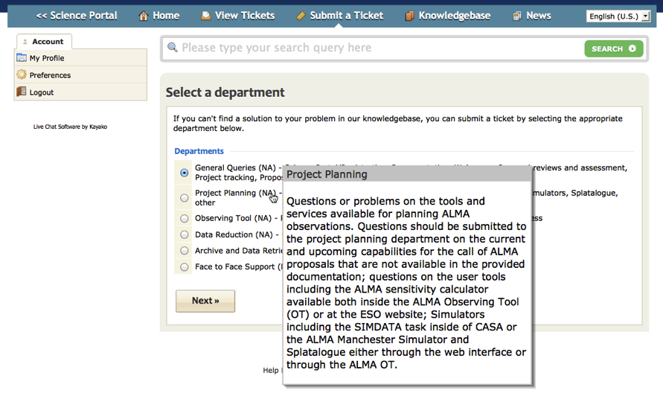
Figure A2: Mouseover “tool tip” view with the scope of the department.
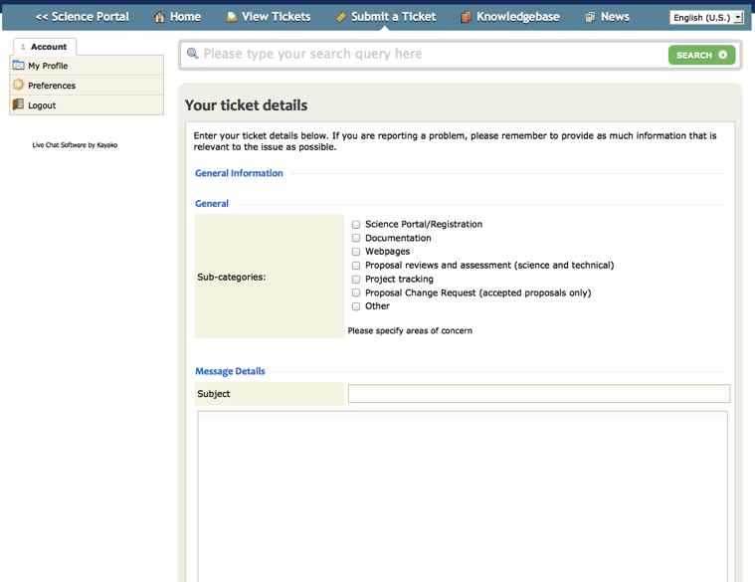
Figure A3: Ticket details entry form for the General Queries Department.

APPENDIX: USS Checklist for Answering Helpdesk Tickets

Checklist for USS in answering a submitted helpdesk ticket:
- Login to the helpdesk (Section 7.1) after you have received your email notification.
- View the ticket (Section 7.4.1)
- Examine it (Section 8.1.1) and take the following actions:
  - If you have enough information, “Reply” to the user (Section 8.1.2) and change the ticket status to “Resolved”.
  - If you need more information from the user, change the ticket status to “Pending” when posting your reply (Section 8.1.3). Wait for the user to respond.
  - If you need to forward the ticket to someone outside the Kayako system, follow the procedure in Section 10.3 and make sure to “Quote” the ticket to send the contents of the correspondence.
  - If you believe the ticket needs to be sent to another ARC, sent to the Proposal Handling Team, or sent to the Change Request Standing Committee (Section 9), change the department to “Return to Triage” (Section 10.2) and add a note explaining why the ticket should be transferred.
  - If you are unable to respond to the ticket (for example, because you lack the specialized knowledge, or because you are unavailable) the ticket should be returned to Triage (Section 10.2) with a note explaining why.
- While posting a reply, determine if the ticket warrants a knowledgebase article (Section 4). If so, save the article as a DRAFT (Section 8.1; Figure 14). DO NOT Publish the article.
- If you are the cognizant lead or a certified USS for a particular software subsystem, you should follow the workflow described in Section 6 and change the ticket status to “Resolved” after reporting the enhancement request or bug fix to the appropriate issue tracking system.
- Repeat accordingly for all your tickets remembering that you have two working days to reply to an assigned ticket before the status changes to “Response Overdue”.
- When you are finished, log out of the helpdesk and go do some science.

APPENDIX: Report and Ticket Tracking Screens
This section contains screenshots of the Report and Ticket Tracking section of the helpdesk.

Figure C1: Level-2 (Triage Staff) Helpdesk Reports Screen

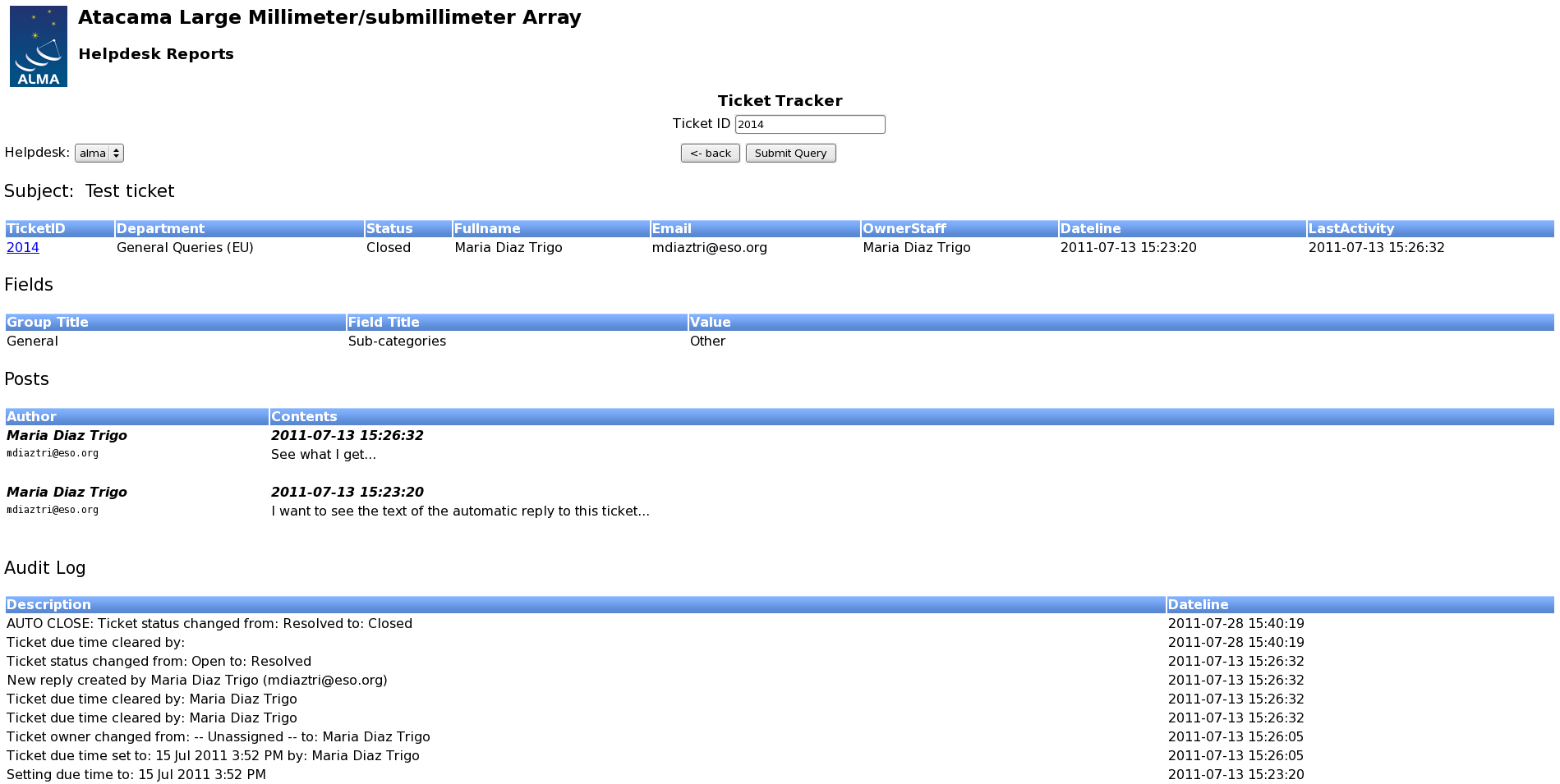
Figure C2: Ticket Tracker page, queries based on ticket number; search results also shown
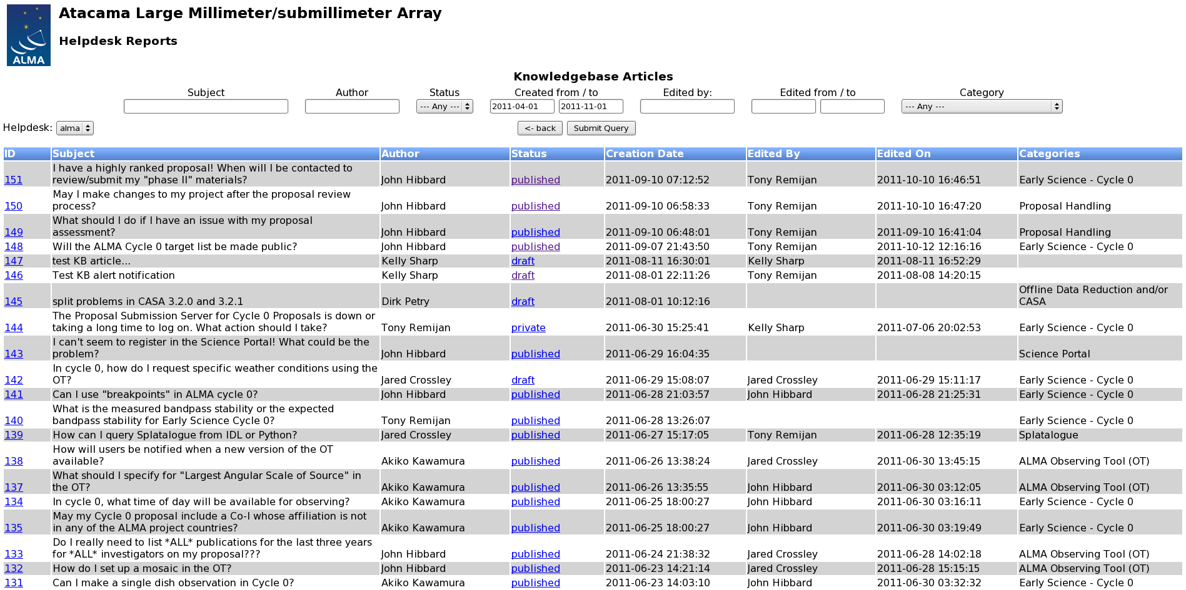
Figure C3: Knowledgebase Articles search query with results

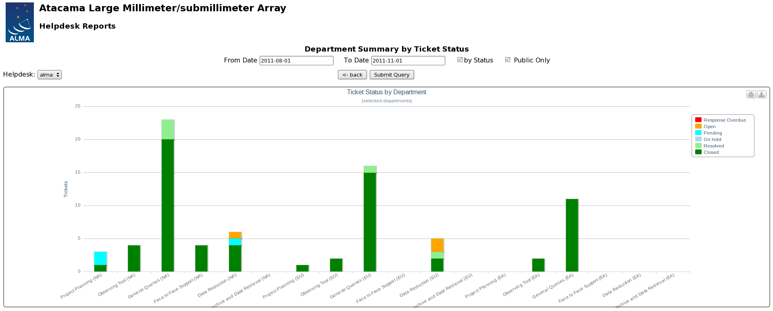
Figure C4: Department summary; grouped by ticket status

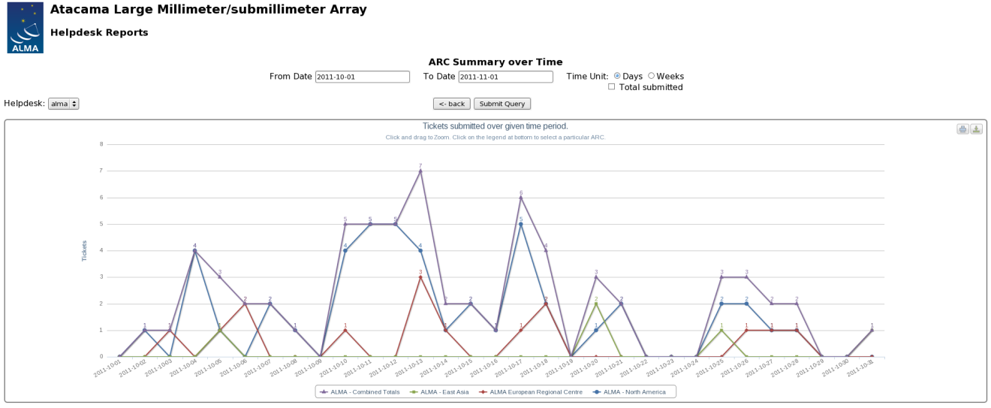
Figure C5: Tickets submitted broken down by day and ARCs

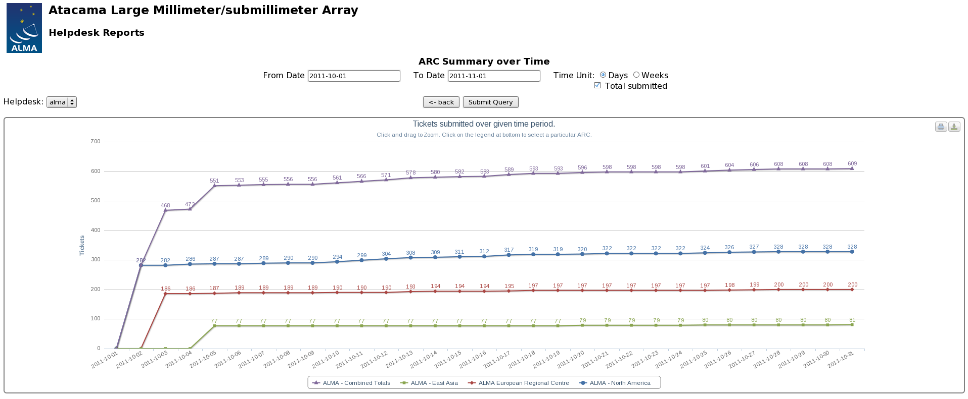
Figure C6: Tickets submitted, summed up over days, broken down by ARC

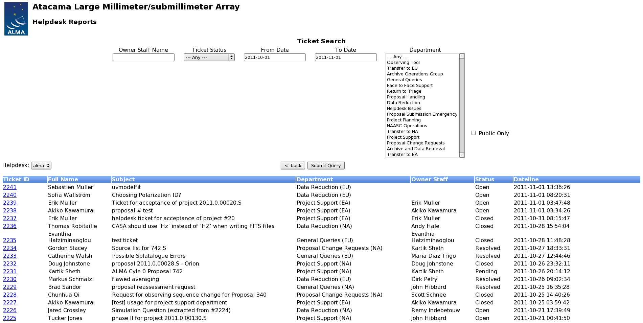
Figure C7: Ticket search; query parameters and results

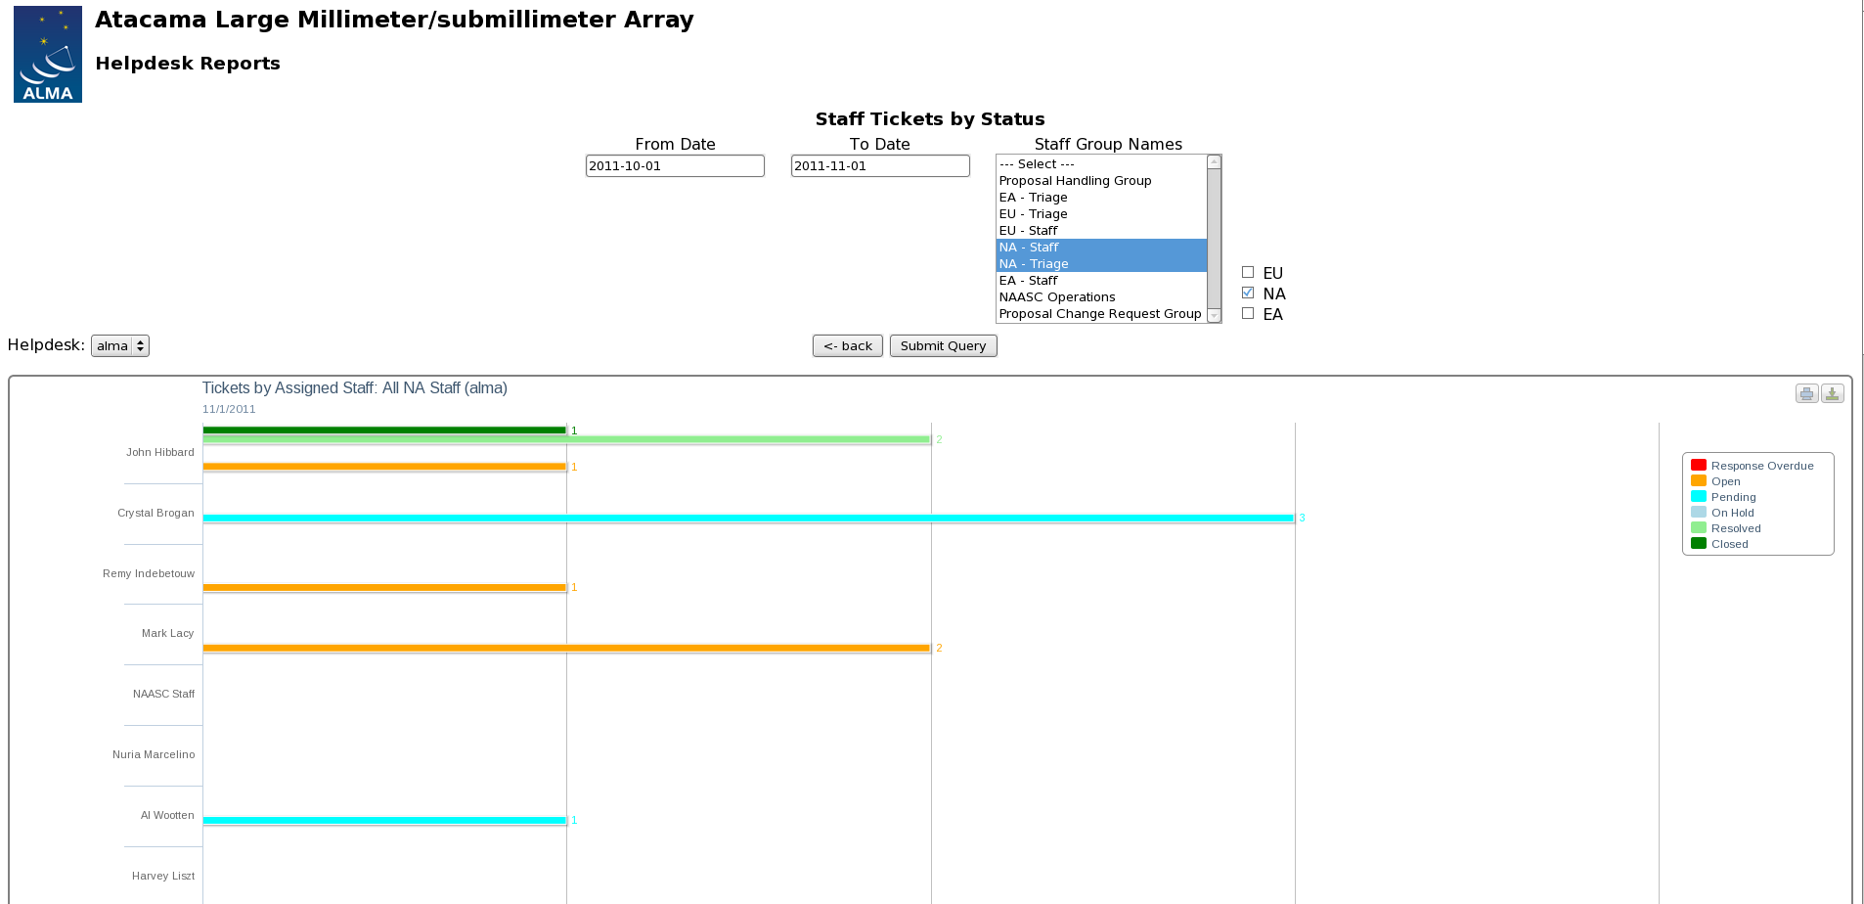
Figure C8: Ticket counts broken down by staff member and ticket status

APPENDIX: Software Bug-Reporting Systems
Information on the various ALMA software systems, including identification of the subsystem scientist, ARC representatives, and links to the bug-reporting system, known issues page, and future developments page, is contained at this wiki page:

http://wikis.alma.cl/bin/view/DSO/SSG_subsystem_description

Information on additional software systems is given below.

When a helpdesk staff person encounters a problem with ALMA software, The Helpdesk Staff Guide describes the appropriate workflow (Section 6), which in general is to transfer the ticket to triage with a note to have it assigned to the subsystem scientist or ARC representative (sometimes this involves first transferring the ticket to a specific ARC). The subsystem scientist or representative then opens a ticket for the software developers in the appropriate bug-reporting system.

SPLATALOGUE
Supported By: | NRAO
Bug-report System Location: | NRAO bug-reporting system
Category: | -
Project: | Splatalog (SPLT)
Component: | -
Who Submits Report: | Transfer to NA ARC; Assign to Splat Subsystem Sci or designee (Remijan)
Request Access from: | Stefan Witz, after approval from Tony Remijan

SIMOBSERVE and SIMANALYZE
Supported By: | NRAO
Bug-report System Location: | NRAO bug-reporting system
Category: | -
Project: | CASA (CAS)
Component: | Simulation
Who Submits Report: | Transfer to NA ARC; Assign to Simdata Subsystem Sci, Remy Indebetouw, or designee.
Request Access from: | Stefan Witz, after approval from Remy Indebetouw

Science Operations
Supported By: | CIPT
Bug-report System Location: | JAO bug-reporting system
Category:
Project: | Science Operations (SCOPS)
Component:
Umbrella Ticket
Who Submits Report:
Request Access from:

http://www.almascience.org/
NOTE: As of the time of this printing, Jun 2, 2013, the NRAO helpdesk reports are not included in the Manager search options.

